Theme/Term | Around The World Autumn 1 |  |  |  | Around The World Autumn 2
Planning Sequence/  Spelling Seed Text | Whole School –Here We Are  Oliver Jeffers  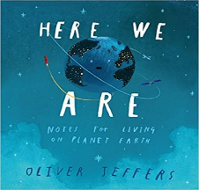 | Naughty Bus- Jan Oke, Jerry Oke  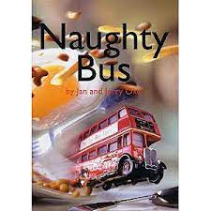 | Iggy Peck Arcitect- Andrea Beatty, David Roberts  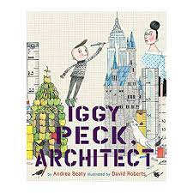 |  | Beegu- Alexis Deacon  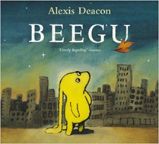 |  | The Snowman  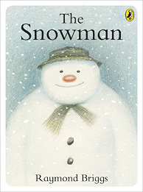
Length | 10 sessions- 2 weeks | 16 sessions- 3 weeks+ | 10 sessions- 2 weeks |  | 10 sessions- 2 weeks |  | 10 sessions – 2 weeks
Outcomes | Leaflet  Lists,  * Geography: Comparing Locations | Own adventure stories  Letters, diaries, non-chronological reports. | Fact files  Labels, captions, character comparisons, thought and speech bubbles. |  | Story sequels  Questions, speech bubbles, letters, lists |  | writing in role; generating dialogue; writing a poem; writing a card and creating a narrative sequel
Theme/Term | Once Upon a Time Spring 1 |  |  |  | Once Upon a Time Spring 2
Planning Sequence/  Spelling Seed Text | 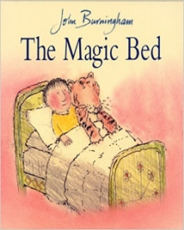  The Magic Bed- John Burningham |  |  | 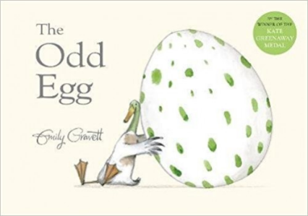 | 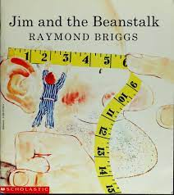 |  | 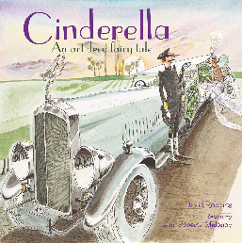
Length | 15 sessions, 3 weeks |  | 10 sessions- 2 weeks |  | 15 sessions- 3 weeks |  | 15 sessions- 3 weeks
Outcomes | Own version fantasy stories  Setting descriptions, additional scenes, description of magical piece of furniture, lists |  | Own version narrative  Thought and speech bubbles, diary entry, letter, certificate |  | Sequel stories  Narrative retellings (including dialogue), thought bubbles, informal letters |  | Character summary  Character descriptions,
Theme/Term | Sailing the Salty Seas Summer 1 |  |  |  | Sailing the Salty Seas Summer 2
Planning Sequence/  Spelling Seed Text | 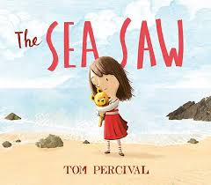 |  |  | 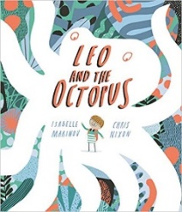  Leo and the Octopus- Isabelle Marinov | 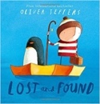 |  | Julian is a mermaid- Jessica Love  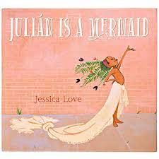
Length | 15 sessions- 3 weeks |  | 15 sessions, 3 weeks |  | 15 sessions, 3 weeks |  | 10+ sessions- 2+ weeks
Outcomes | Own version narrative  Writing in role, notes of advice, missing posters, diary entries, letters of thanks |  | Fact file  This is Me! posters, letters of advice, factual descriptions, logbooks, scripts |  | Own version ‘losing/finding’ narratives Character descriptions, retellings, advice, instructions, non-chronological reports |  | Three-verse poems  Instructions, writing in role, advertisements

