Theme/Term | The World Autumn 1 |  |  |  |  | The World & Christmas Autumn 2
Planning Sequence | 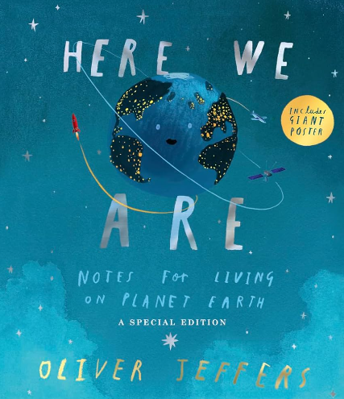  Here We Are  Oliver Jeffers  Whole School Text |  |  |  | 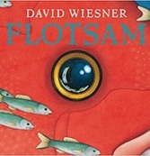  Flotsam  David Wiesner | 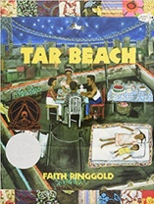  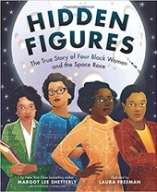  Tar Beach  Faith Ringgold |  | The Snowman  Raymond Briggs  Whole School Text
Length | 8 sessions, 2 weeks |  |  |  | 15 sessions, 3 weeks | 15 sessions, 3 weeks |  | 10 sessions 2 weeks
Outcomes | Poster, Poem/Song Verses leaflet |  |  |  | Sequels (mystery)  Postcard, setting descriptions, non- chronological reports, message in a bottle letters | Narrative retelling as a play script  Poetry, setting descriptions, formal letters, dialogue (as a script) |  | Instructional writing, writing in role, generating dialogue, writing a poem
Literacy Leaf Text
Theme/Term | Spring 1 – Ancient Civilisations |  |  |  |  | Spring 2 – Ancient Civilisations
Planning Sequence | 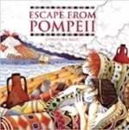  Escape from Pompeii  Christina Balit | History  Ancient Rome |  |  | 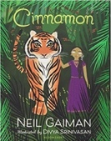  Cinnamon  Neil Gaiman | 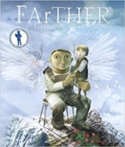  FArTHER  Grahame Baker Smith |  | 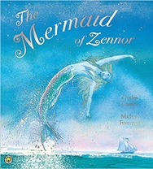  The Mermaid of Zennor  Charles Causley
Length | 16 sessions, 3+ weeks |  |  |  | 15 sessions 3 weeks | 15 sessions, 3 weeks |  | 15 sessions 3 weeks
Outcomes | Newspaper reports  Setting descriptions, diaries, letters, thought bubbles |  |  |  | Own version fables  Diaries, informal letters, dialogue, adverts, limericks and other poetic forms | Sequel stories  Retellings, recounts (postcards), setting descriptions, diary entries, instructions |  | Own version legends  Information booklets, retelling from a different perspective, letters, tourist guides updates, dialogue
Literary Leaf Text | 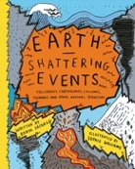  Earth Shattering Events  Robin Jacobs |  |  | 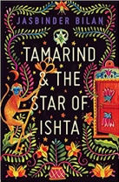  Tamarind and the Star of Ishta  Jasbinder Bilan |  | 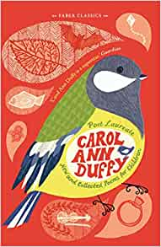  New and Collected Poems for Children  Carol Ann Duffy
Theme/Term | Summer 1 – We are Biologists |  |  |  |  | Summer 2 – We Are Biologists
Planning Sequence | 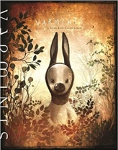  Varmints  Helen Ward |  |  | 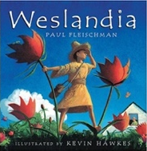  Weslandia  Paul Fleischman |  | 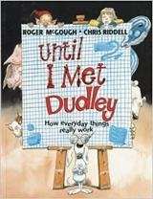  Until I Met Dudley  Roger McGough and Chris Riddell | 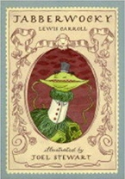  Jabberwocky  Lewis Carroll
Length | 16 sessions 3+weeks |  |  |  |  | 10 sessions, 2 weeks | 15 sessions, 3 weeks
Outcomes | Explanations of a life cycle  Diary entries, instructions, letters, descriptions, speeches |  |  | Imagined land narratives  Character description, informative posters, persuasive leaflets, logbook |  | Two explanation texts - formal and informal  Letters, short explanatory paragraphs | Nonsense poems  Performance poetry, explanatory descriptions
Literacy Leaf Text | 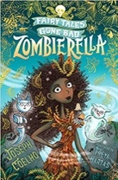 |  |  | 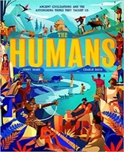  The Humans: Ancient civilisations  Jonny Marx |  | 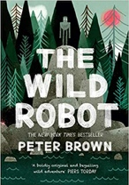  The Wild Robot  Peter Brown | 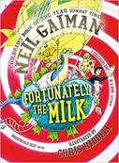  Fortunately, the Milk  Neil Gaiman

