
Tintwistle C. E. (A) Primary School

11.3.21
Welcome Back!
It has been lovely to have all the children back in school and we have been very pleased with how well they have settled. We have also welcomed several new arrivals so we are busier than ever. We are really looking forward to taking even more steps towards normality, allowing the classes to mix and getting together for assemblies and school events will feel like such a treat when we finally get there. We are also hoping that it won’t be too long before parents can join us again, we hope to plan something nice in the summer term if possible.

It’s a Pond!
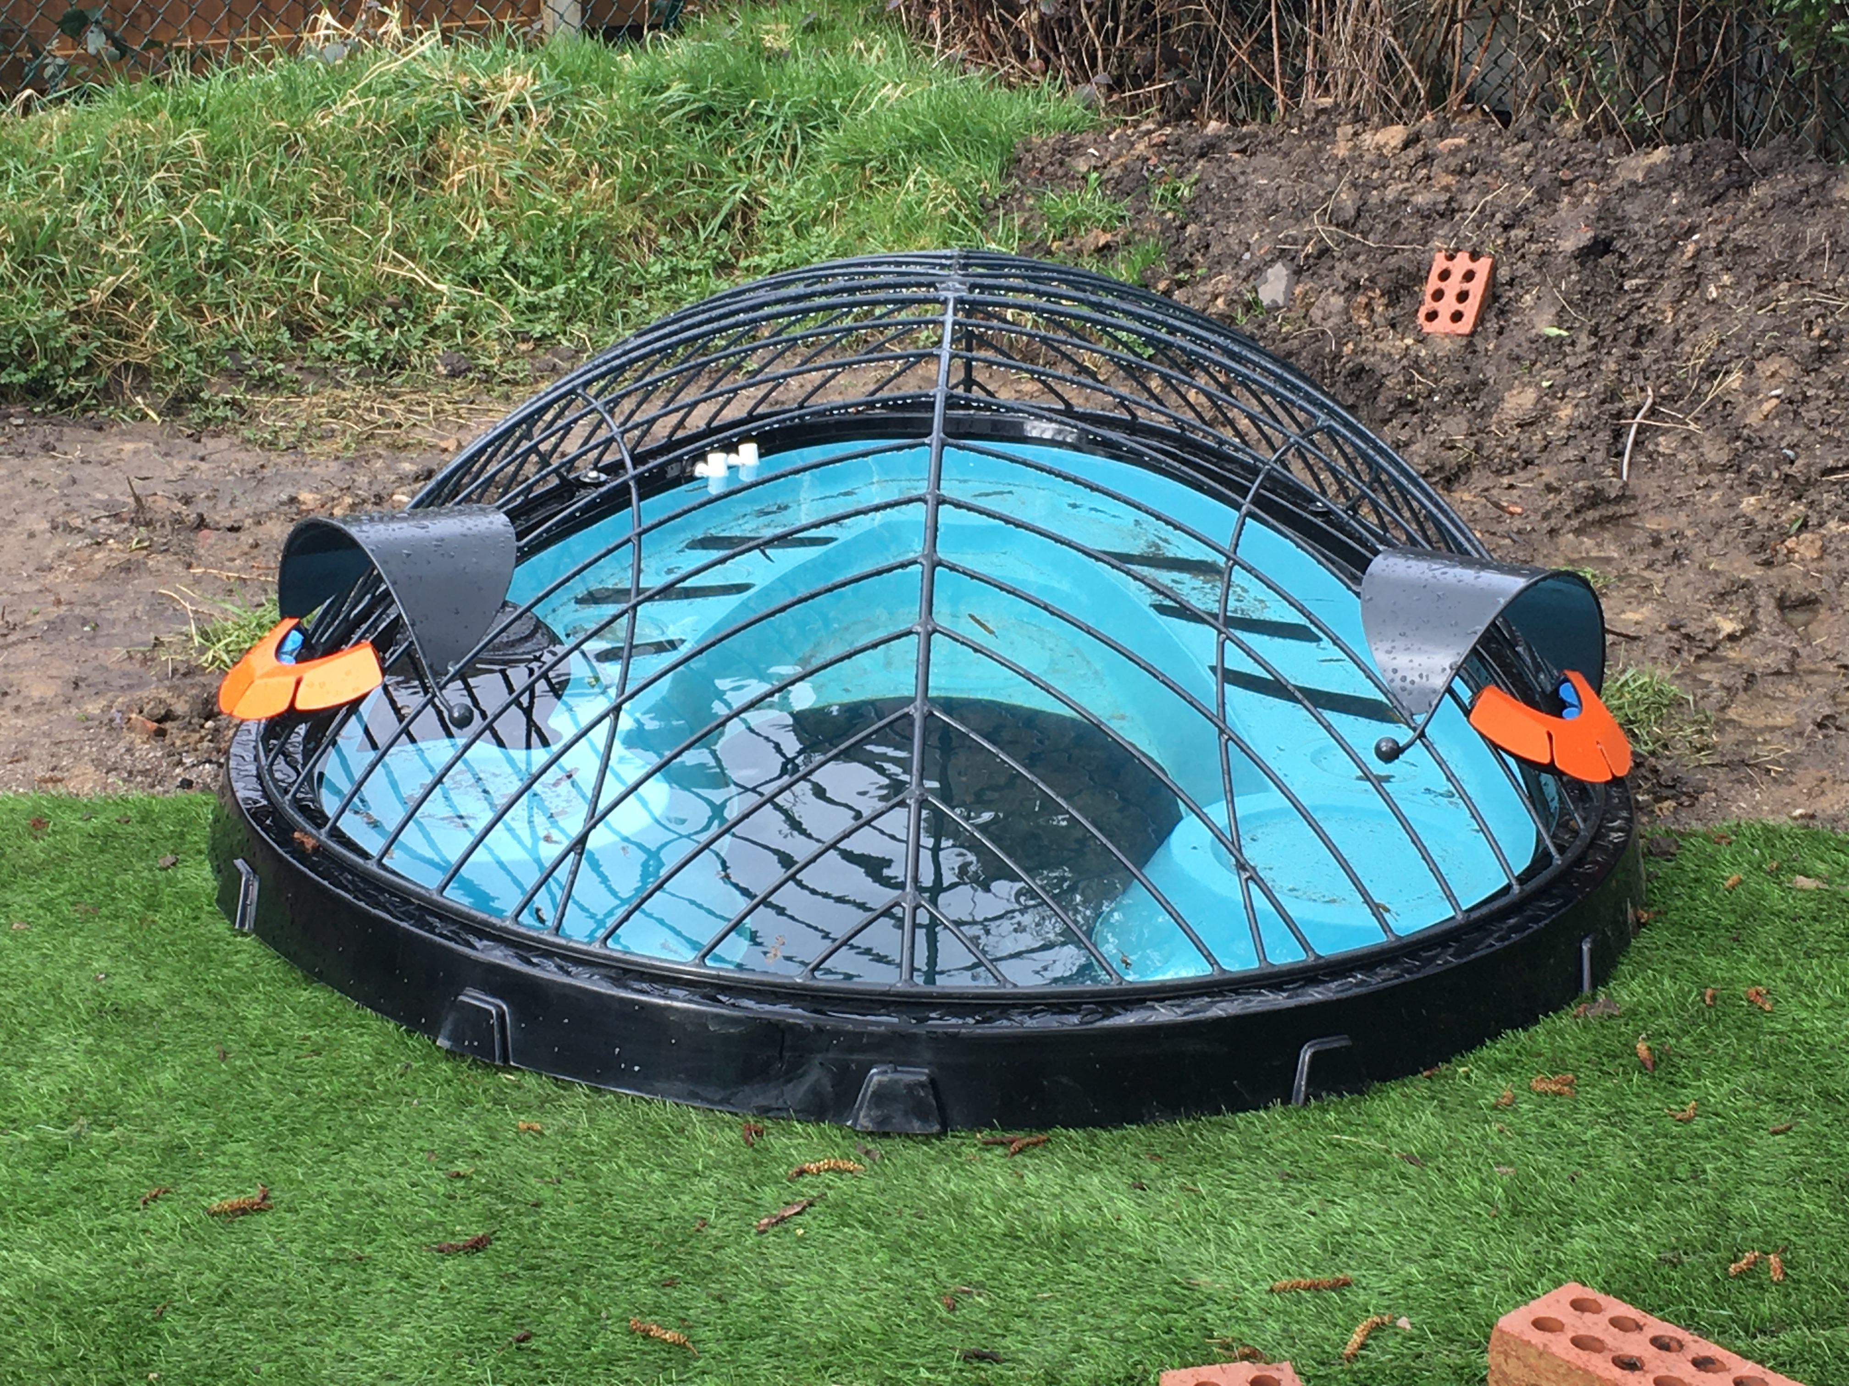
Our mystery item is now in place and although we managed to convince many of the children that it’s a jacuzzi for the teachers it is in fact a Bugzone pond. The pond is specially designed to be safe for children and the front half of the cover can be removed for pond dipping. It is blue to make it easier for the children to see the tiny creatures but it will look much more natural once we have all the plants in place. We will also be planting up the area around it and hope to encourage lots of wildlife. Big thanks to Mr Bott and Miss Corkin for all their digging – it really was quite a challenge!
Comic Relief
Children (and adults) are welcome to come in non-uniform and/or with crazy hair on Friday 19th March in aid of Comic Relief. Voluntary donations of £1 would be welcomed. Please remember that clothes and shoes must be suitable for playing out in and bellies must be covered – no crop tops please!

Sports Clubs
National guidance states that we are not currently allowed to offer after school sports clubs, Active Tameside will resume on 30th March for Class 3 (the Y3/4 bubble) when the rules will be updated.

Virtual Parents’ Evening
Our telephone parents’ evenings will take place in the final week of term, your child should have brought home a letter from their class teacher inviting you to book an appointment. Please let us know if you haven’t received a letter and we will send a replacement. The teachers are not all making their calls on the same days so please note that sibling appointments will not be linked and may be on different days.

White Hall 2021
Could all parents of Y4 and Y5 children who would like them to participate in the Y5/6 residential trip to White Hall in October 2021 please ensure that booking forms are returned and deposits paid as soon as possible please. We anticipate being able to take all the children who want to go but as we are limited to 24 spaces priority will be given to Y5 (who will be Y6 when the trip is held) as long as they have booked places before the Easter holiday. All those children from both Y4 and Y5 who have already booked have been allocated places.

Jo Griffin, Headteacher

Dates for Your Diary

Thursday 1st April School closes for Easter
Monday 19th April School re-opens
Monday 3rd May Early May Bank Holiday
Friday 28th May School closes for Whit
Monday 7th June School re-opens
Friday 25th June School closed for staff training
Wednesday 21st July School closes for summer holiday for children
Thursday 22nd July Staff training day
Wednesday 1st September School closed for staff training*
Thursday 2nd September School re-opens for children

*Please note that this is a slight change to the Derbyshire County Council holiday pattern. Staff are returning a day early in September and school will close one day earlier for Christmas on Wednesday 22nd December. The total number of teaching days will remain unchanged. This has been done so that children are in school on both Thursday 2nd September and Friday 3rd September rather than returning for just one day in the first week.

