Theme/Term | Location, Location, Location Autumn 1 |  |  |  |  | Marvellous Me Autumn 2
Planning Sequence | 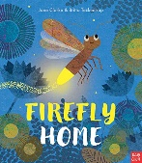  Firefly Home by Jane Clarke  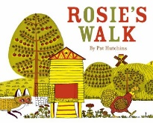  Rosie’s walk by Pat Hutchins |  | 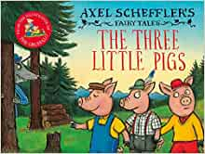  The Three Little Pigs by Axel Schefflers | 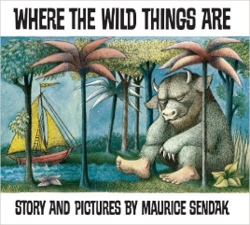  Where the wild things are by by Maurice Sendak |  | 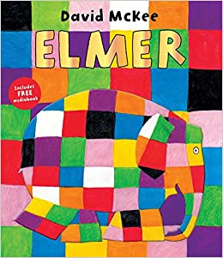  Elmer by David McKee | 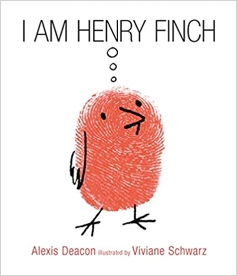  I am Henry Finch  Alexis Deacon | 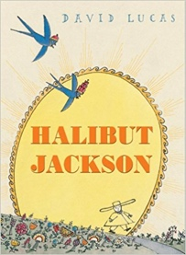  Halibut Jackson  David Lucas
Length | 5 sessions per book, 2+weeks |  | 10+ sessions, 2+weeks | 10+ sessions, 2+weeks |  | 10+ sessions, 2+weeks | 10+ sessions, 2+weeks | 10+ sessions, 2+ weeks
Outcomes | Firefly’s Journey- Story map of the Firefly’s journey. Initial sounds for labels.  Rosie’s walk- Story sequencing, instructions. |  | Information leaflets  Labels and captions, retellings, story sequencing, role play characters | Own version ‘wild thing’ narratives  Labels, captions, oral re-telling, developing a new character |  | Non-chronological reports  Dialogue, diaries, re-telling (oral dictation) | Guidebooks - How to Think  Timetables, thought-bubbles, lists, commands, letters of advice | Narrative sequels  Signs and labels, captions, invitations, thought bubbles, advertisements, letters of advice
Theme/Term | Wild and Wonderful Beasts Spring 1 |  |  |  |  | On the Move Spring 2
Planning Sequence | 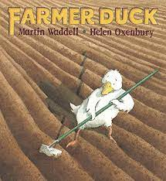  Farmer Duck by Martian Waddell |  | 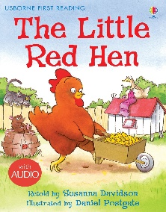  The Little Red Hen | 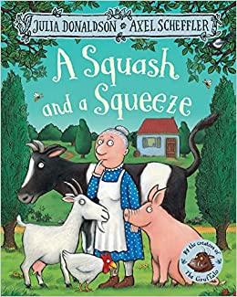  A Squash and Squeeze by Julia Donaldson |  | Naughty Bus by  Jan and Jerry Oke | 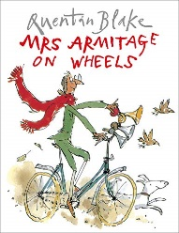  Mrs Armitage on Wheels by Quentin Blake | 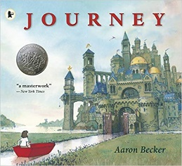  Journey by Aaron Becker
Length | 10+ sessions, 2+weeks |  | 10+ sessions, 2+weeks | 10+ sessions, 2+ weeks |  | 10+ sessions, 2+weeks | 10+ sessions, 2+weeks | 10+ sessions, 2+ weeks
Outcomes | Own version ‘overcoming’ tales  Thought bubbles, labels, oral re-telling, writing in role, letters to the Farmer |  | Alternative character versions  speech bubbles, role play characters | Rhyming  Act out the story, rhyming activities |  | Recount  Write a recount of where the bus has been, feelings of the characters, orally recall the book sequence. | Instructions  Instructions on how to build a bike, story maps. | Diary  Predictions, retellings in role, maps, posters, a travel diary.
Theme/Term | Exploring in the garden Summer 1 |  |  |  |  | Oh I do like to be beside the seaside Summer 2
Planning Sequence | 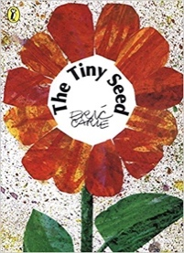  The Tiny Seed by Eric Carle | 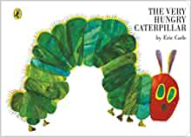  The Very Hungry Caterpillar |  |  | 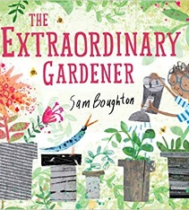  The Extraordinary Gardener  Sam Boughton | 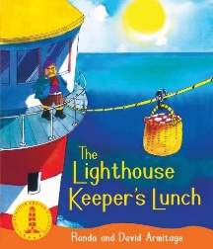  The Lighthouse Keeper’s Lunch  by Ronda Armitage | 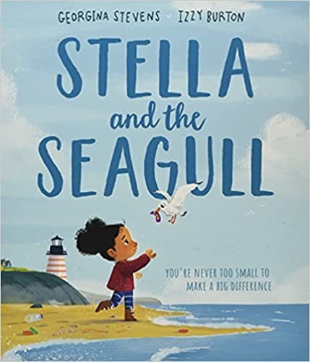  Stella and the Seagull by Georgina Stevens | 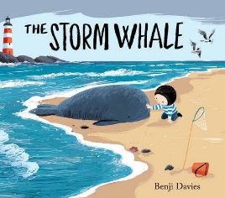  The Storm Whale by Benji Davies
Length | 10+ sessions, 2+weeks | 10+ sessions, 2+weeks |  |  | 10+ sessions, 2+weeks | 10+ sessions, 2+weeks | 10+ sessions, 2+weeks | 10+ sessions, 2+ weeks
Outcomes | Advice leaflets  Labels and captions, advice, retellings, writing in role, narrative, letter | Alternative version narratives  Character description, writing in role, letters, leaflets |  |  | Narrative inspired by the original text  Labels, letters of advice, instructions, narratives | Lists  Writing shopping lists/recipes, diary entry. | Simple explanation  Signage, letters of advice, lists, labelled diagrams | Poetry  About the whale-acoustic poem, retelling the story from another character’s point of view.

