STheme/Term | The World – Autumn 1 |  |  |  |  |  | The World Autumn 2  Galimoto  Karen Lynn Williams
Writing Root /  Spelling Seed Text | Here We Are  Oliver Jeffers  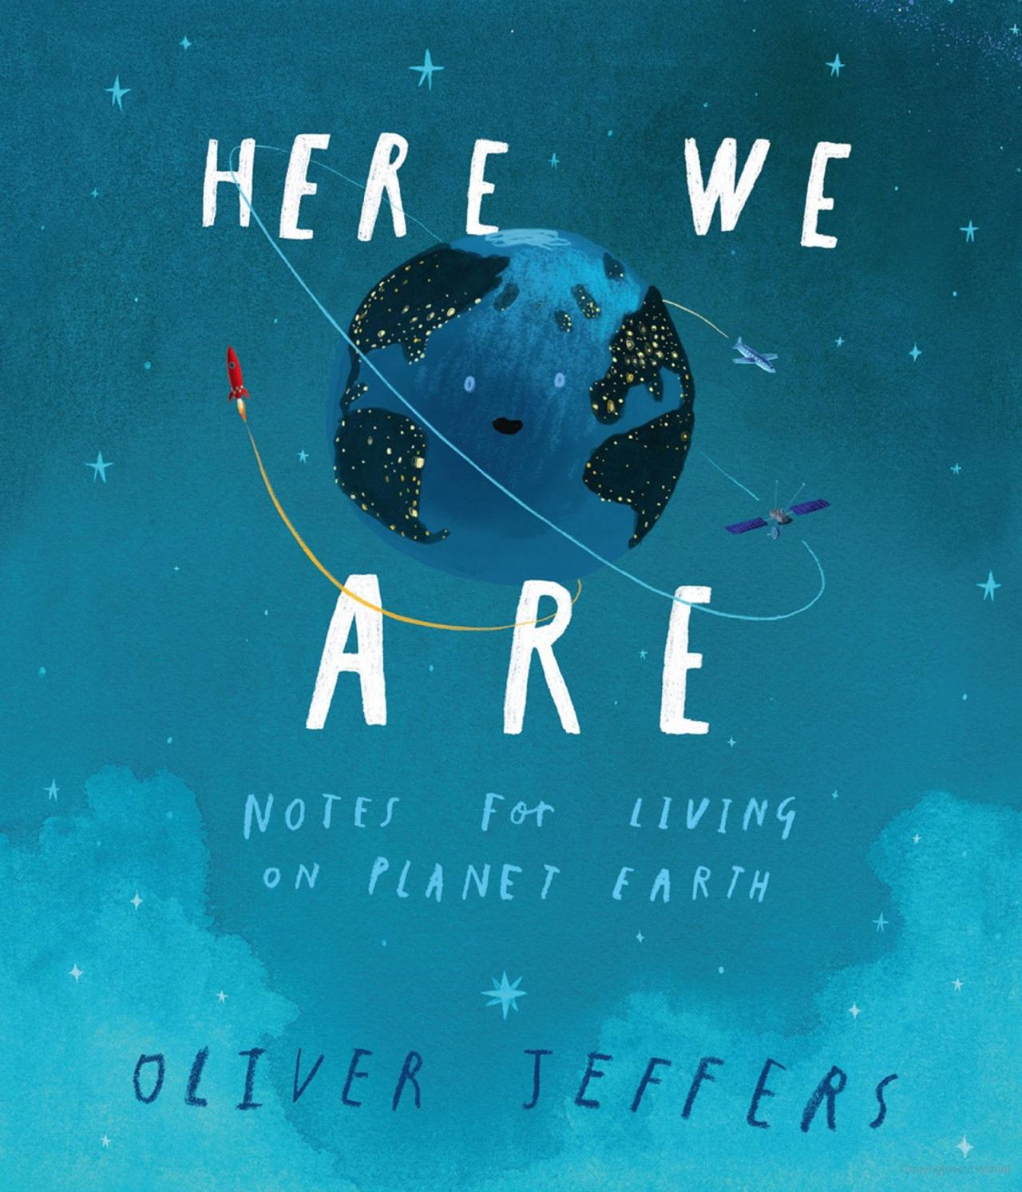 |  | 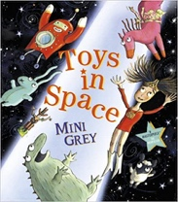  Toys in Space | Geography  Human/Physical | 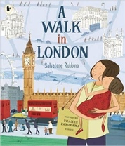  OR A Walk in London  Salvatore Rubbino |  | 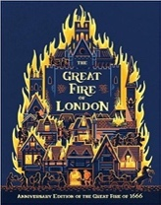  The Great Fire of London  Emma Adams |  | History  GFoL | 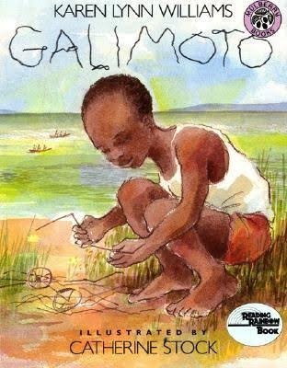 Galimoto  Galimoto  Karen Lynn Williams |  |  | 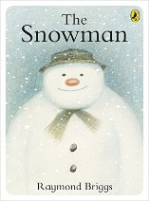  The Snowman  Raymond  Briggs  Whole school Text |  | SEASONAL
Length | 2 Weeks |  | 15 sessions, 3 weeks |  | 15 sessions, 3 weeks |  | 15 sessions, 3 weeks |  |  | 15 sessions, 2 weeks |  |  | 10 Sessions 2 weeks
Outcomes | Poster, Poem/Song Verses leaflet |  | Own version fantasy world narrative  Found posters, diary entries, speech bubbles, notes of advice, space logs, invitations, fantasy setting descriptions |  | A Walk in…’ tour guide  Instructions, persuasive poster, setting descriptions, captions, postcards, diary entry |  | Information booklets  Persuasive poster, warning posters (instructional writing), speech bubbles, letter of advice, certificates |  |  | African Story.  Instruction writing/explanation text |  |  | Instruction writing
Theme/Term | Fairytales, Dragons and Castles! - Spring 1 |  |  |  |  |  | Fairytales, Dragons and Castles! Spring 2
Writing Root /  Spelling Seed Text | 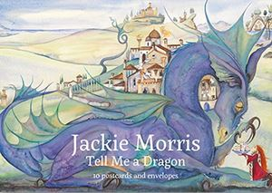  Tell Me A Dragon  Jackie Morris |  | 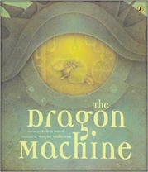  The Dragon Machine  Helen Ward |  |  |  | 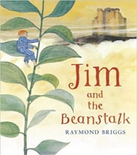 | Jim and the Beanstalk  Raymond Briggs |  |  |  | 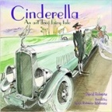  Cinderella An Art Deco Fairy Tale  Lynn Roberts and David Roberts |  | 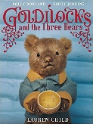  Or Goldilocks  Lauren Child
Length | 15 sessions, 2 weeks |  | 15 sessions, 3weeks |  |  |  | 15 sessions, 3 weeks |  |  |  |  |  |  | 10 sessions, 2 weeks
Outcomes | Expanded noun phrases, descriptions, apostrophe for possession. |  | Own version dragon stories  Dragon guides & encyclopaedia, letters of advice, dragon machine explanations, shopping lists, |  |  |  | Sequel stories  Narrative retellings (including dialogue), thought bubbles, informal letters |  |  |  |  | Literary Leaf -Reading Outcomes Making predictions, inferences and summarising
Theme/Term | Ship Ahoy! Summer 1 |  |  |  |  |  | Ship Ahoy! Summer 2
Writing Root /  Spelling Seed Text | 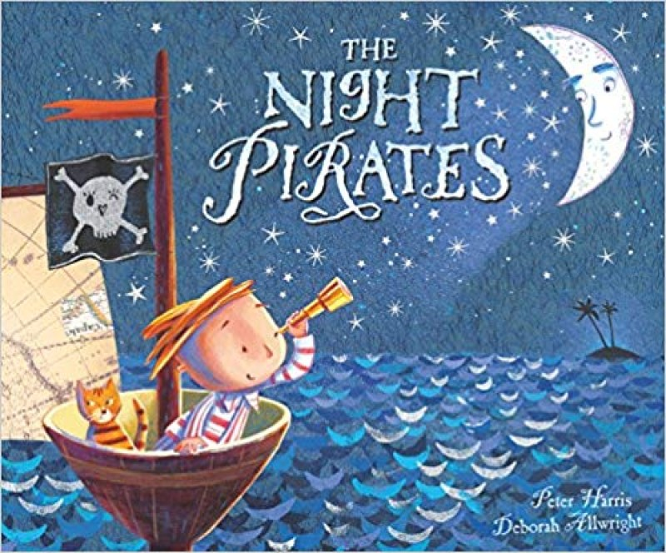 | 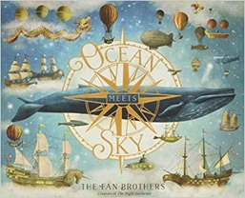  Ocean Meets Sky  Eric Fan and Terry Fan |  |  |  |  | 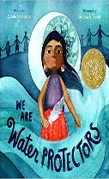  We Are Water Protectors  Carol Lindstrom |  |  | 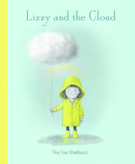  Lizzy and the Cloud  The Fan Brothers |  |  | 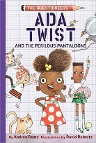  Ada Twist  Andrea Beaty  (Link to Science) |  | SCIENCE
Length | 10 sessions – 2 weeks | 15 sessions, 3 weeks |  |  |  |  | 15 sessions, 3 weeks |  |  | 15 sessions, 3 weeks |  |  | 12 sessions,
Outcomes | How to be a Pirate Guide  Writing in Role  Letters | Own version fantasy world narratives  Setting & character descriptions, labels, diaries, postcards, captain’s logs, instructions, dialogue |  |  |  |  | Environmental campaign List poems, non-chronological reports (animals), chron reports (life-cycles), character descriptions, protest signs |  |  | COMING SOON |  |  | Used at the end of Y2 asit has some Y3 content. Questions, predictions, scientific knowledge and concepts. Inference and prediction.

