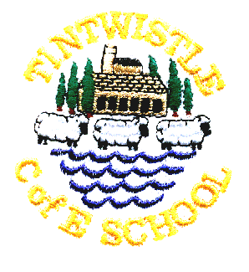
Tintwistle C. E. (A) Primary School
‘Confidence, Competence, Creativity’

21st November 2018

Non Uniform Day Thursday 29th November
Children are invited to come in non-uniform in return for bottles (full please!) for our bottle stall at the fair.

Theatre Performance in School
Tutti Frutti will be bringing their Christmas show to us again this year on Friday 30th November, we are very much looking forward to The Snow Queen. We have invited Padfield Primary to an afternoon performance so there is likely to be additional traffic at home time, please be patient. Thanks to the PTA for funding this very popular event.

Christmas Fair in School – Friday 30th November 5.00pm -7.00pm
Everyone welcome to come along and get festive. Stalls, refreshments, children’s games and a chance to meet Father Christmas!

Christmas Dinner in School - Wednesday 19th December
All children who normally have a school meal will automatically be served a Christmas dinner (vegetarian option available). If your child normally brings a packed lunch but would like a dinner please order on the slip overleaf and send in £2.10 in a named envelope.

Christmas Play
This year’s play is ‘Stable Manners’ and all the children in the school, including nursery, are involved. Please let us know if your child is unable to attend all the performances so that we can make alternative arrangements. Monday’s performance is a dress rehearsal and is a little unpolished, but it is a good opportunity to bring younger siblings and we often have spare seats. Please do not bring babies to the evening performances as they often disturb the show and it is unfair to the children. The good news is that tickets are free, but seats are strictly limited due to fire regulations, we are happy to accommodate wheelchairs but it is helpful if you let us know when booking (just note it on the slip).

School Carol Service – Wednesday 19th December
Please meet at Christ Church at 9.00am, everyone welcome. If you would like to wear your Christmas jumper any donations made for Christmas Jumper Day will be sent to Save the Children.

School closes for Christmas at 3.30pm on Friday 21st December and re-opens on Monday 7th January.

Child’s name …………………………………………………………… Class …………………………………………………….

Please send me the following tickets Spares (if any
(maximum 2 per family, pick one date) available, maximum 2)

Monday 10th December at 2.00pm ……………. ……………

Tuesday 11th December at 6.30pm ……………. ……………

Thursday 13th December at 6.30pm ……………. ……………

No more than 2 tickets in each column (apologies if you think it is obvious but columns go downwards, rows go across. Ticking every box will not get you extra tickets!)

Please note that tickets will be issued on Thursday 6th December. We always have spare seats for the Monday afternoon performance so it is possible to request more seats for that date.

Child’s name …………………………………………………………. Class ………………………………………………………..

My child would like to order a Christmas dinner on Wednesday 19th December and I enclose £2.10

