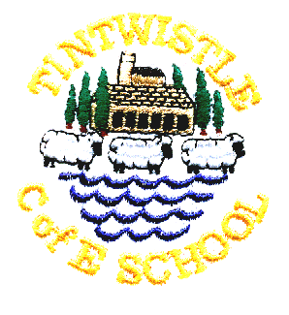
Tintwistle C. E. (A) Primary School

‘We learn and grow best together, with God, in a family of all
kinds of people, surrounded by encouragement and love.’
9.11.21

Harvest Gifts
Thank you to everyone who donated to our foodbank collection, all donations are being distributed through the food bank at St Mary’s Church in Hollingworth.

Memorial Service at the Cenotaph
The children will be walking up from school to sing a song at the cenotaph and lay a wreath on Thursday morning. We will be leaving after registration and so will probably be there around 9:45am. Parents are welcome to join us, please try to maintain social distancing. Classes 1 and 2 will be visiting Christ Church on their way back to school.

Arrangements for Christmas
We have made many of our normal Christmas arrangements this year but we will have to make decisions about parents joining us for events nearer the time based on the ongoing covid situation and advice that we receive. I have included a list of diary dates below. Our Christmas play will be filmed and available to view via a link whether or not we are able to have an audience.

For environmental reasons we will be asking the children not to distribute Christmas cards in school again this year – we will find alternative ways for them to send their Christmas greetings.

The children will be making lanterns in school for the lantern parade on Saturday 4th December and will bring these home on Friday 3rd December, if you have any old jam jars at home please send them in and we will get artistic! Battery tea lights will be provided at the event.

We have taken the decision not to hold a Christmas Fair this year for covid reasons but we are very much hoping to recruit a new PTA in the New Year and plan some social events. Please let me know if you are interested in joining the PTA and we can arrange a meeting date.

School Christmas dinner will be on Wednesday 15th December, this will automatically be served to all children who normally have a school dinner and a vegetarian option is available. There will also be a special party dinner on Wednesday 22nd December. If your child does not normally have a school dinner and you would like to order either of these dinners please do so on the slip at the end of this newsletter and return in a named envelope, enclosing £2.20 for each meal ordered (Reception, Y1 and Y2 are free).

Jo Griffin, Headteacher

Child’s name: Class:

Please tick as appropriate
- I would like to order a Christmas dinner for my child
- I would like to order a party dinner for my child

Signed: parent/guardian

Dates for Your Diary

Thursday 11th November The children will be singing at the war memorial at around 9:45am, socially distanced parents welcome!
Friday 19th November Non-uniform day for Children in Need
Friday 3rd December Children to visit Christmas Tree Festival at Christ Church
No after school club available
Saturday 4th December Lantern parade from Conduit Street
Monday 6th December Pantomime in school
Monday 13th December Christmas play afternoon performance*
Tuesday 14th December Christmas play evening performance*
Wednesday 15th December Christmas dinner in school
Thursday 16th December Christmas play evening performance*
Wednesday 22nd December Christmas service at Christ Church*
Parties in school, Christmas jumper day.

*Subject to covid 19 restrictions/advice

Polite request – please could you ensure that we have up to date phone numbers, there have been several times recently when we have not been able to contact parents.

Please do not use the app for our text service, we have found that parents using the app do not receive notifications of messages.

