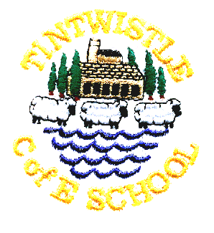
Tintwistle C. E. (A) Primary School
Parents’ and Carers’ Survey 2020

We’d like to know what you think about our school, and any ideas you may have about ways to improve it. We have run similar surveys before and the results were very useful, so we’ve decided to repeat the exercise and monitor any changes.
Please be reassured that all of your comments are grouped together, the data analysed as a whole and responses anonymised.
Please can you leave your completed form in the boxes provided. Thank you.

Please put a tick in the relevant box for each statement. You can use a separate form for each child if you feel the answers differ.
 | Strongly agree | Agree | Disagree | Strongly  disagree | Don’t  know
My child is happy in school
My child feels safe in school
My child is making good progress
My child is well looked after at school
The school makes sure its pupils are well behaved
School deals effectively with bullying*
My child is taught well at this school
I get valuable information about my child’s progress
I feel well informed about what’s going on in school
The school responds well to any concerns I raise
I’m comfortable going in to school to discuss anything
My child receives appropriate homework for their age
The school is well led and managed
The school seeks the views of parents and takes into account their suggestions and concerns
Staff encourage my child to become mature and independent
There is a good range of activities that my child finds interesting and enjoyable
The arrangements for my child to settle in when they started school were good
The school has made their values clear to parents and pupils
(*includes persistent name calling, cyber bullying, racist and homophobic bullying)

Would you recommend this school to other parents? (please tick)
_ Yes _ No

These questions are about the religious aspects of our school
 | Yes | No | Don’t  know
Did you know that we are a Church of England school
Does the leadership promote the school as a church school
The school offers good support for the spiritual, moral, social and
cultural development of pupils
The school has lots of links with the local churches
My child enjoys the collective worship assemblies
I’m kept well informed about the work my child does in Religious Education (RE)
When you visit, you can tell the school is a Church school

Do you want to say anything else about our school? Please do not refer to individual members of staff by name. If you feel you have an issue that requires a direct response please make an appointment to see Mrs. Griffin or add your name so we can contact you.
Good points about the school are …

Any further comments, suggestions or issues the school could consider?

The website is full of helpful information – newsletters, events calendar, school policies, useful links to other websites, photographs, examples of work by children at the school.
Have you used the school’s website tintwistle.eschools.co.uk/website? (please tick)
_ Yes, I’ve used it _ No, but I was aware of it _ No, didn’t know about it

