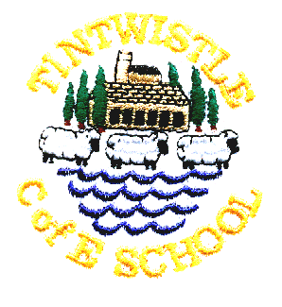
Tintwistle C. E. (A) Primary School
‘Confidence, Competence, Creativity’

21st November 2017

Non Uniform Day and Christmas Fair – Friday 1st December
Children are invited to come in non-uniform in return for bottles (full please!) for our bottle stall at the fair. Our Christmas Fair will be held from 5.00pm to 7.00pm.

Willow Wood Flumpets
We have a variety of new Willow Wood snowman beanies for sale priced at £1.50.

Christmas Dinner in School - Friday 15th December
All children who normally have a school meal will automatically be served a Christmas dinner (vegetarian option available). If your child normally brings a packed lunch but would like a dinner please order on the slip overleaf and send in £2 in a named envelope.

Christmas Play
This year’s play is ‘Straw and Order’ and all the children in the school, including nursery, are involved. Please let us know if your child is unable to attend all the performances so that we can make alternative arrangements. Monday’s performance is a dress rehearsal and is a little unpolished, but it is a good opportunity to bring younger siblings and we often have spare seats. Please do not bring babies to the evening performances as they often disturb the show and it is unfair to the children. The good news is that tickets are free, but seats are strictly limited due to fire regulations, we are happy to accommodate wheelchairs but it is helpful if you let us know when booking (just note it on the slip).

School Carol Service – Tuesday 19th December
Please meet at Christ Church at 9.00am, everyone welcome. If you would like to wear your Christmas jumper any donations made for Christmas Jumper Day will be sent to Save the Children.

Christ Church Christmas Services
Carols by Candlelight Sunday 10th December at 6.30pm, refreshments to follow
Christmas Eve Communion at 9.15am
Christmas Day Christmas Communion at 10.30am

School closes at 3.30pm on Tuesday 19th December and re-opens at 8.55am on Wednesday 3rd January

Theatre Performance in School
Tutti Frutti will be bringing their Christmas show to us again this year on Tuesday 9th January. We have invited Padfield Primary to an afternoon performance so there is likely to be additional traffic at home time, please be patient. Thanks to the PTA for funding this very popular event

Child’s name …………………………………………………………… Class …………………………………………………….

Please send me the following tickets Spares (if any
(maximum 2 per family, pick one date) available, maximum 2)

Monday 11th December at 2.00pm ……………. ……………

Tuesday 12th December at 6.30pm ……………. ……………

Thursday 14th December at 6.30pm ……………. ……………

No more than 2 tickets in each column (apologies if you think it is obvious but columns go downwards, rows go across. Ticking every box will not get you extra tickets!)

Please note that tickets will be issued on Thursday 7th December. We always have spare seats for the Monday afternoon performance so it is possible to request more seats for that date.

Child’s name …………………………………………………………. Class ………………………………………………………..

My child would like to order a Christmas dinner on Thursday 15th December and I enclose £2

