Theme/Term | The World Autumn 1 |  |  |  | Marvellous Me Autumn 2
Planning Sequence | 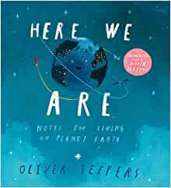  Here we are by Oliver Jeffers | 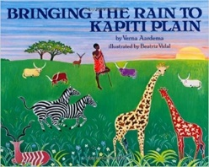  Bringing the Rain to Kapiti Plain by  Verma Aardema | 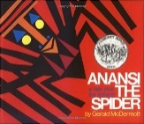  Anansi by  Gerald McDermott | Seasonal Book  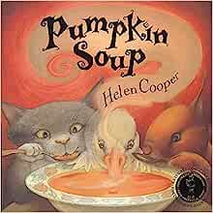  Pumpkin Soup by Helen Cooper bybybfjd | 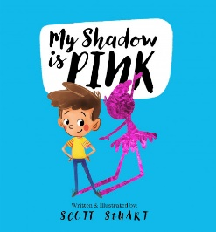  My shadow is pink by Scott Stuart | 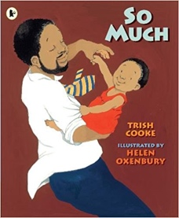  So Much  Trish Cooke and Helen Oxenbury | 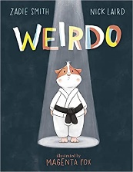  Weirdo Zadie Smith and Nick Laird | Seasonal book-TBC
Length | 10+ sessions, 2+weeks | 10+ sessions, 2+weeks | 10+ sessions, 2+weeks | 5 sessions, 1 week | 10+ sessions, 2+weeks | 10+ sessions, 2+weeks | 10+ sessions, 2+ weeks
Outcomes | Own version ‘wild thing’ narratives  Labels, captions, oral re-telling, developing a new character | Tourist information leaflets  Labels and captions, retellings, simple explanations | Booklets about spiders  Labels and captions, call-and-response poems, descriptive posters, simple explanations | Lists on what we need to make pumpkin soup, children to follow a recipe. | Innovated spoken rhymes, questions, notes of advice, lists, instructions | Own ‘So Much’ narrative poems  Past tense sentences, writing in role, performance/ narrative poetry | Instructional guides to being brave  Writing in role, letters, captions and labels, narrative retellings
Theme/Term | Once upon a time Spring 1 |  |  |  | To infinity and beyond Spring 2
Planning Sequence | 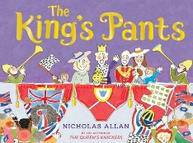  The King’s Pants by Nicholas Allen | 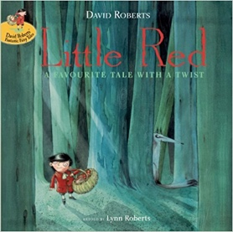  Little Red by  Lynn Roberts and David Roberts | 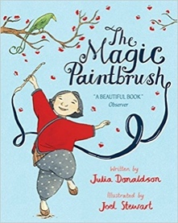  The Magic Paintbrush by  Julia Donaldson and Joel Stewart |  | 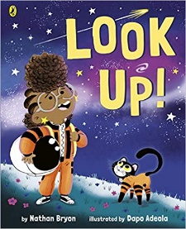  Look up! by  Nathan Bryon and Dapo Adeola | 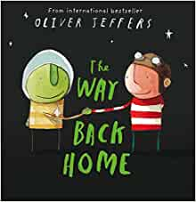  The way back home by Oliver Jeffers | 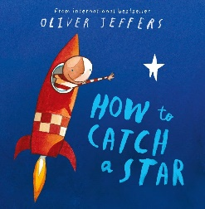  How to catch a star by Oliver Jeffers
Length | 10+ sessions, 2+weeks | 10+ sessions, 2+weeks | 10+ sessions, 2+ weeks |  | 10+ sessions, 2+weeks | 10+ sessions, 2+weeks | 10+ sessions, 2+ weeks
Outcomes | Writing letters, designed new under pants and add descriptive sentences. | Alternative character versions  Labels, notes of advice, adverts | Own version ‘overcoming’ tales  Thought bubbles, labels, oral re-telling, writing in role, thank you letters |  | Non-chronological reports  Dialogue, diaries, re-telling (oral dictation), mini-autobiography, ship’s log | Own stories about a fussy eaters  Statements, writing in role, shopping lists | Narrative inspired by the original text  Labels, letters of advice, instructions, narratives
Theme/Term | Sailing the Seven Seas Summer 1 |  |  |  | Super heroes Summer 2
Planning Sequence | 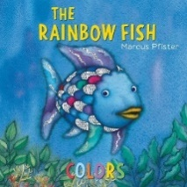  The Rainbow Fish by Marcus Pfister | 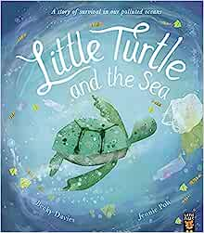  Little Turtle and the Sea by Becky Davies | 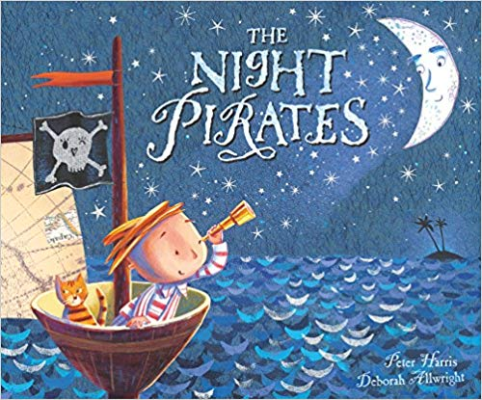  The Night Pirates by  Pete Harris and Deborah Allwright |  | Super Milly and the Super School Day by  Stephanie Clarkson  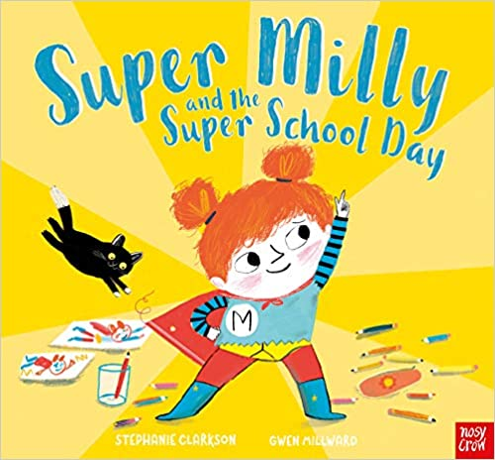 | 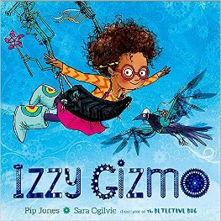  Izzy Gizmo by Pip Jones | 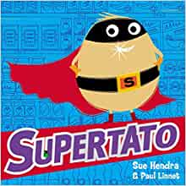  Supertato by Sue Hendra
Length | 10+ sessions, 2+weeks | 10+ sessions, 2+weeks | 10+ sessions, 2+weeks |  | 10+ sessions, 2+weeks | 10+ sessions, 2+weeks | 10+ sessions, 2+ weeks
Outcomes | Fact file about fish, descriptive writing, learn new vocabulary. | Poster on preventing plastic pollution. | ‘How to be a pirate’ guides  Writing in role, letters, labels and captions |  | Alternative character version  Letters of encouragement; a retelling; song lyrics and job applications | Signage, letters of advice, lists, labelled diagrams | Adverts, descriptive writing.

