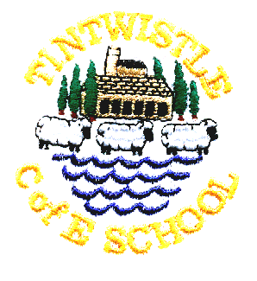
Tintwistle C. E. (A) Primary School
‘Confidence, Competence, Creativity

7th October 2016

Parents’ Evenings – 17th and 19th October
Your online login should be attached to this email, please book your appointment online. If your child has two teachers we recommend that you see your child’s literacy and numeracy teacher but you are of course welcome to see both.
Go to ‘tintwistle.eschools.co.uk’
Log in using your login details.
Click on the ‘parents evening’ tab on the blue bar at the top of the page
Click view event bookings
Click on your child’s name
Click book/view
Use the drop down menu to pick the teacher you want to see
Then click on the time you want and click save.
Your appointment has been booked.
If you are booking to see another teacher follow the steps again but choose the other teacher from the drop down menu.

At parents evening we will be serving tea and cakes in the hall and running a book swap of both adult and children’s books so please bring along any books you have finished with. Donations of cakes are also very welcome. We will also be demonstrating our new Reading Cloud system.

Reading Cloud
This is a web based system which children and parents can access anywhere. The address is http://u011997.microlibrarian.net and there is a link on our website. The number is our unique school number; alternatively you could search Micro Librarian and put Tintwistle into the site box.
Through Reading Cloud your child can blog (posts can only be read by other children in school that they have registered as friends), review, check out recommended reads and reserve books in our library. If you download the Micro Librarian app you can scan books in a bookshop to see if we have them in the library and either reserve them or request that we purchase.

Your child’s username is and their password is the same number if they are in class 3 or 4.
If they are in class 1 or 2 their password is cat because individual passwords are too tricky for our youngest pupils.

We hope that as well as promoting the enjoyment of reading the children will start to learn how to use social media responsibly and safely through Reading Cloud. For further advice on keeping your child safe online please visit the links section on our website.

Playing Out
School staff and visitors have been increasingly concerned about the number of ‘near misses’ they are seeing after school when children are playing out around the turning circle and on Woodlands. Please do remind your child that this is a road and the cars come down very fast.

