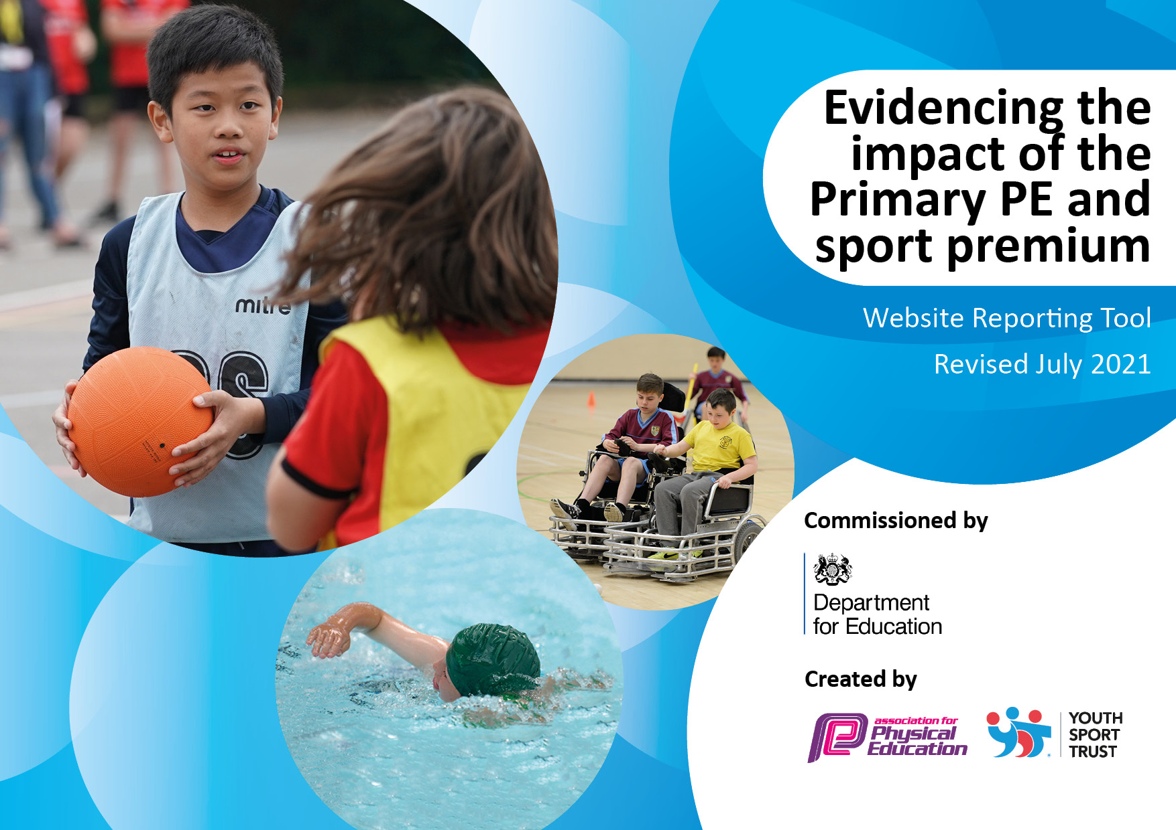
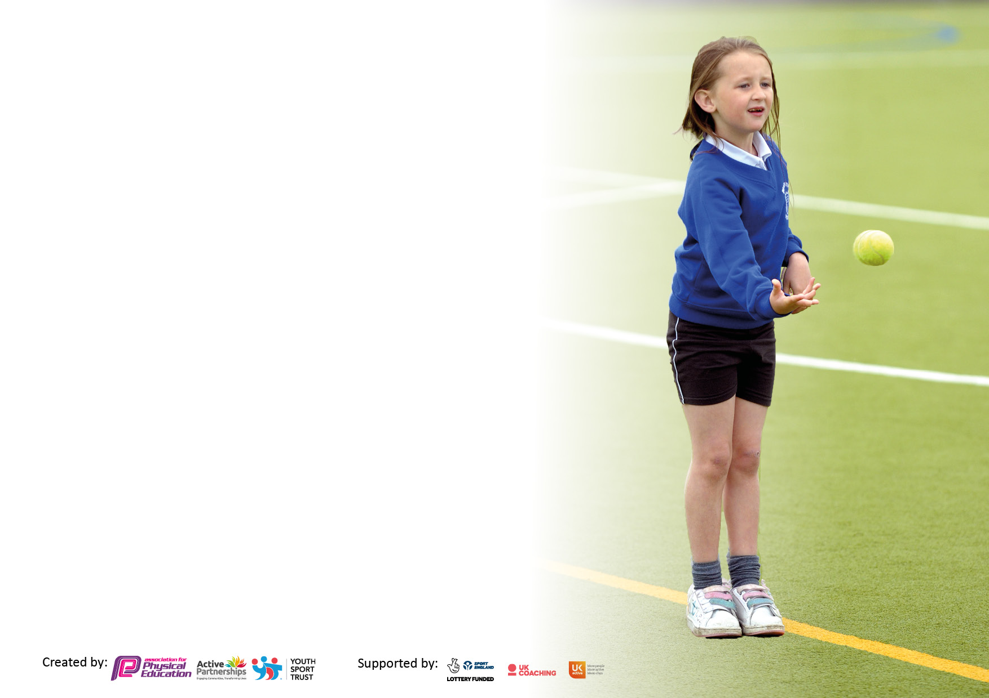

It is important that your grant is used effectively and based on school need. The Education Inspection Framework makes clear there will be a focus on ‘whether leaders and those responsible for governors all understand their respective roles and perform these in a way that enhances the effectiveness of the school’.

Under the Quality of Education Ofsted inspectors consider:
Intent - Curriculum design, coverage and appropriateness
Implementation - Curriculum delivery, Teaching (pedagogy) and Assessment
Impact - Attainment and progress

To assist schools with common transferable language this template has been developed to utilise the same three headings which should make your plans easily transferable between working documents.

Schools must use the funding to make additional and sustainable improvements to the quality of Physical Education, School Sport and Physical Activity (PESSPA) they offer. This means that you should use the Primary PE and sport premium to:

- Develop or add to the PESSPA activities that your school already offer
- Build capacity and capability within the school to ensure that improvements made now will benefit pupils joining the school in future years
- The Primary PE and sport premium should not be used to fund capital spend projects; the school’s budget should fund these.

Pleasevisitgov.ukfortherevisedDfEguidanceincludingthe5keyindicatorsacrosswhichschoolsshoulddemonstrate animprovement.Thisdocumentwillhelpyoutoreviewyourprovisionandtoreportyourspend.DfEencouragesschools to use this template as an effective way of meeting the reporting requirements of the Primary PE and sport premium.

We recommend you start by reflecting on the impact of current provision and reviewing the previous spend.

Schools are required to publish details of how they spend this funding, including any under-spend from 2019/2020, as well as on the impact it has on pupils’ PE and sport participation and attainment. All funding must be spent by 31st July 2022.

We recommend regularly updating the table and publishing it on your website throughout the year. This evidences your ongoing self-evaluation of how you are using the funding to secure maximum, sustainable impact. Final copy must be posted on your website by the end of the academic year and no later than the 31st July 2021. To see an example of how to complete the table please click HERE.

Details with regard to funding
Please complete the table below.

Total amount carried over from 2019/20 | £0
Total amount allocated for 2020/21 | £16820
How much (if any) do you intend to carry over from this total fund into 2021/22? | £6373.50
Total amount allocated for 2021/22 | £23193.50
Total amount of funding for 2021/22. To be spent and reported on by 31st July 2022. | £16820
Swimming Data
Please report on your Swimming Data below.

Meeting national curriculum requirements for swimming and water safety.

N.B. Complete this section to your best ability. For example you might have practised safe self-rescue techniques on dry land which you can then transfer to the pool when school swimming restarts.
Due to exceptional circumstances priority should be given to ensuring that pupils can perform safe self rescue even if they do not fully meet the first two requirements of the NC programme of study
What percentage of your current Year 6 cohort swim competently, confidently and proficiently over a distance of at least 25 metres?  N.B. Even though your pupils may swim in another year please report on their attainment on leaving primary school at the end of the summer term 2020.  Please see note above | 83%
What percentage of your current Year 6 cohort use a range of strokes effectively [for example, front crawl, backstroke and breaststroke]?  Please see note above | 83%
What percentage of your current Year 6 cohort perform safe self-rescue in different water-based situations? | 94%
Schools can choose to use the Primary PE and sport premium to provide additional provision for swimming but this must be for activity over and above the national curriculum requirements. Have you used it in this way? | Yes/No

Action Plan and Budget Tracking
Capture your intended annual spend against the 5 key indicators. Clarify the success criteria and evidence of impact that you intend to measure to evaluate for pupils today and for the future.

Academic Year: 2020/21 | Total fund allocated: | Date Updated:
Key indicator 1: The engagement of all pupils in regular physical activity – Chief Medical Officers guidelines recommend that primary school pupils undertake at least 30 minutes of physical activity a day in school |  |  |  | Percentage of total allocation:
 |  |  |  | %
Intent | Implementation |  | Impact
Your school focus should be clear what you want the pupils to know and be able to do and about  what they need to learn and to  consolidate through practice: | Make sure your actions to achieve are linked to your intentions: | Funding allocated: | Evidence of impact: what do pupils now know and what can they now do? What has changed?: | Sustainability and suggested next steps:
Daily mile track is used for 10 minutes each day for each class.  Use external coaches to provide high quality PE sessions and School Sport (extra-curricular) opportunities for all children.  Continue to provide high quality PE/ Forest school resources.  Residential trip to Whitehall | Timetable for the mile track.  - Active Tameside run a weekly after school club. Active Tameside have taught P.E sessions to the whole school on a timetable throughout the whole school year.  We have used the money to ensure all children have access to a Forest School. All equipment is replenished yearly or when needed. We have also brought a new P.E scheme- ‘Get set 4 P.E.’ This has had a huge impact across the whole school.  -Audit of P.E equipment.  Year 5/6 children went to Whitehall for 3 days. | £3500  £1300 (P.E scheme-over three years.)  £3623.20 | Children are able to beat their personal best scores on the mile track. All children are able to access the mile track. EYFS children are secure when using the mile track.  Children have enjoyed PE lessons taught by Active Tameside and the sports club is popular.  -Children are able to be involved with Forest School activities, using the correct equipment.  -The P.E scheme has helped with staff’s confidence when teaching P.E. It has ensures there is clear skills based progression throughout the school.  The children were able to completed lots of new experiences at Whitehall. It was a great opportunity for them. | To continue to integrate the mile track into a school day. Most classes use the mile track, monitor each class using the track. Ensure timetable is clear. Train middays to get involved at lunch times.  To continue having Active Tameside in on a Tuesday. Change the sports that they teach and use as CPD for staff.  To have a shelter built in the forest school garden, to ensure children are able to access sessions in all weathers.  To continue to use the P.E scheme, introducing vocabulary within each year group. Train new staff up to use the new scheme.  To continue provide children with new opportunities. We have a sport weeks planned this year too.
Key indicator 2: The profile of PESSPA being raised across the school as a tool for whole school improvement |  |  |  | Percentage of total allocation:
 |  |  |  | %
Intent | Implementation |  | Impact
Your school focus should be clear what you want the pupils to know and be able to do and about  what they need to learn and to  consolidate through practice: | Make sure your actions to achieve are linked to your intentions: | Funding allocated: | Evidence of impact: what do pupils now know and what can they now do? What has changed?: | Sustainability and suggested next steps:
Continue to employ Play leader/replenish stock (where necessary).  To provide children in Year 5 with leadership opportunities.  Weekly swimming sessions for the Y5/6 children. | Sports council to order new playtime equipment with SJ.  -Dawn Richardson came into school to deliver leadership training for the Year 5 children.  Children have been swimming every Thursday morning. | £300  £200  £4687 | Children enjoyed having autonomy of ordering equipment. They completed an audit and enjoyed having a budget and catalogue to order equipment.  - Successfully completed – children now more confident in providing children with outside activities –to train next year’s Year 5. Children lead at lunchtimes/playtimes and in lessons.  Children have made excellent progress with their swimming. See percentages above. | To continue this next year. SJ to have over to the new subject leader.  Staff to ensure playground leaders are completing their roles and are making sure equipment is used correctly and tidied away correctly. Assembly to highlight this and meeting with staff.  To continue to ensure Y5/6 children attend weekly swimming sessions.

Key indicator 3: Increased confidence, knowledge and skills of all staff in teaching PE and sport |  |  |  | Percentage of total allocation:
 |  |  |  | %
Intent | Implementation |  | Impact
Your school focus should be clear | Make sure your actions to | Funding | Evidence of impact: what do | Sustainability and suggested
what you want the pupils to know | achieve are linked to your | allocated: | pupils now know and what | next steps:
and be able to do and about | intentions: |  | can they now do? What has
what they need to learn and to |  |  | changed?:
consolidate through practice:
Continue to provide high quality training for all teaching staff to ensure that all children receive high quality PE and Sport provision.  Continue to release all staff to ensure that pupils can attend a range of sporting opportunities throughout the year/CPD. | Staff have all completed training to deliver the ‘Get set 4 PE’ scheme.  Mrs Doyle, Mrs Pickering and Sue. | Training was free.  £500 | - High quality sports provision in place.  -Teachers having more confidence and skills.  -Use High Peak SSP to provide high quality CPD.  Children are able to participate in many sporting activities around the local area and within the high peak. | To renew cheerleading  qualifications.  To continue to release staff for P.E events, where possible.
Key indicator 4: Broader experience of a range of sports and activities offered to all pupils |  |  |  | Percentage of total allocation:
Intent | Implementation |  | Impact
Your school focus should be clear | Make sure your actions to | Funding | Evidence of impact: what do | Sustainability and suggested
what you want the pupils to know | achieve are linked to your | allocated: | pupils now know and what | next steps:
and be able to do and about what they need to learn and to consolidate through practice:  Further develop our ‘Try something new week’ promoting local sporting clubs. | intentions:  Cyclo cross  Archery  All stars cricket | £500  £500 | can they now do? What has changed?  Children enjoyed participating in new activities. Many children have joined new clubs. | Continue with trying new sports next year.
Additional achievements: | ‘Making Space’ dance event- Transport  Mossy Lea- Transport  Table Tennis bats (for all children) | £250  £475  £195.49 | Children enjoyed performing at Buxton Opera House. For many children it was a new experience.  Children enjoyed the trip and it was an enriching experience for all.  ‘The Friends of Tintwistle’ have asked for all children to have a table tennis bat, for them to be able to access the table tennis table in the local park. | Continue to participate with the ‘Making Space Event.’  To continue to ensure local trips are provided to the children.  The children are able to use their local facilities correctly, using their own bat.

Key indicator 5: Increased participation in competitive sport |  |  |  | Percentage of total allocation:
 |  |  |  | %
Intent | Implementation |  | Impact
Your school focus should be clear | Make sure your actions to | Funding | Evidence of impact: what do | Sustainability and suggested
what you want the pupils to know | achieve are linked to your | allocated: | pupils now know and what | next steps:
and be able to do and about | intentions: |  | can they now do? What has
what they need to learn and to |  |  | changed?:
consolidate through practice:
School to buy into Glossopdale SSCO provision to enable a wide range of inter school sporting activities.  School to continue to buy into High Peak School Sport Partnership to enable a wider range of competitions and resources. | Football league for Y5/6 boys and girls.  Cricket KS1/KS2  Quad kids  Rugby event  Tennis festival  Key steps gymnastics  Cheerfest | £ 500 (releasing staff) | -More children attending sporting activities at other schools.  -More children competing with other schools. | To continue to compete in a range of events next year.

Signed off by
Head Teacher: | J.Griffin
Date: | 06/07.2022
Subject Leader: | Sophie Jones
Date: | 05/07/2022
Governor:
Date:

