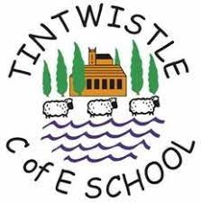
Science: IMPACT
The impact of our science curriculum means that all children at At Tintwistle C.E. (A) Primary School will:
Know more, understand more and remember more about science.
Have a secure understanding of each key block of knowledge and the concepts covered in their year-group.
Develop the full range of working scientific skills that enable them to work independently.
Display confidence and enjoyment in science.
Use and apply their science knowledge and skills across the curriculum, making meaningful connections between subjects.

