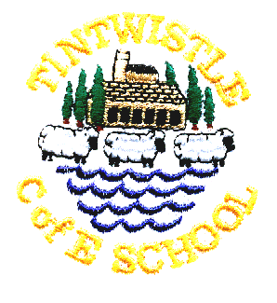
Tintwistle C. E. (A) Primary School
‘Confidence, Competence, Creativity’

Newsletter number 19 19th February 2015

Parent Survey
Thanks to all those parents who completed surveys, we really do value your feedback. The governors’ evaluation of the survey is on the reverse of this newsletter. As so many parents are now accessing the website this is the last paper newsletter we will be sending out. We will text on a Thursday for the next couple of weeks to remind you to check the website. Paper copies will be available from the office if anyone needs one.

Parent Governor Elections
Please note that all nominations for parent governor should be received by 12.00 noon on Friday 27th February. If there are multiple nominations we will be issuing ballot papers on Monday 2nd March which must be returned by 12.00 noon on Monday 9th March.

Class 3 learn about Fairtrade at URC
On Tuesday afternoon class 3 walked up to URC to take part in activities which were designed to help them learn about Fairtrade. The children had a great time and would like to thank the team at URC for their hospitality.

Change 4 Life Champions
Issy, Ebony, Danny and Ellis have been selected as our school Change 4 Life Champions and will be attending a conference in Matlock on Friday. They will then be leading activities in school and trying to encourage us all to eat more healthily and get active!

Gala Princess/Queen
Entry forms for this year’s gala princess are available from the office. This year’s gala will be held on Saturday 27th June. The children are also beginning to work on their mug designs for the competition; this year’s mug theme is Ladybird books: fairy-tales and stories. The school will be entering a float in the parade again this year, theme to be decided.

World Book Day
World Book Day will be on Thursday 5th March. The children will be engaged in book related activities in school and we are inviting them to dress up as their favourite book character. There will also be a competition for the best potato dressed as a book character!

Comic Relief
This year’s Red Nose Day will be on Friday 13th March. If your child wishes to dress up we will collect donations for Comic Relief. Please note that due to the large amount that we would have to order we will not be selling red noses in school.

Easter Bonnets
For those competitive parents who like to plan ahead (mentioning no names!) this year’s Easter competition will be hats and will be judged on Thursday 26th March.

Jo Griffin, Headteacher

