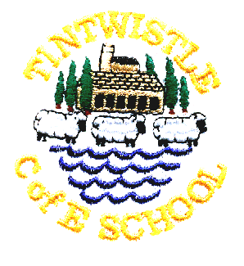
Tintwistle C. E. (A) Primary School

18.3.20
Coronavirus Update

As you will all be aware school will be closed to all but the children of key workers and those deemed vulnerable at the end of the school day on Friday.

Some schools will be clustering together to provide cover, others will be remaining separate. Our staff have decided that they would rather care for the children at Tintwistle as this will be more familiar for them and will reduce the risk of the virus spreading. Staff will be working on a rota basis and several have already self-isolated. This is an emergency service for those who would be unable to work in key roles without childcare, please do not try to enrol your child if you are not a key worker or are able to arrange other care. We will not be open to any children over the Easter holiday, we will be signposting key workers to other, larger, local schools which will be remaining open.

We will not be offering the full curriculum and are aiming to keep the number of children to a minimum in order to maintain the purpose of closing the school. The last thing that we want to do is encourage the spread of the virus to the children of key workers who will then infect their parents. Please do not be offended if you are asked for proof of your job, this is the joint policy of Glossop schools.

Please see the DCC definition of key workers below:

We are still awaiting the full list from the Cabinet Office but understand that the Government has defined those as teachers, teaching assistants supporting those with EHCPs, health workers, social care workers (both children’s services and adult services), carers such as foster carers, blue light services and those who provide vital logistical supplies such as delivery drivers and utilities engineers.

We are aware that many employers are telling their employees that they are key workers in order to maintain business continuity and would like to reiterate that this is an emergency service only, families should follow social distancing guidelines wherever possible.

Parents of children in receipt of free school meals will be provided with vouchers but the government has still to decide how this will work, we hope to be able to have this in place before the close of school tomorrow. If anybody feels that they will have difficulty affording food, either due to the absence of school meals or hardship due to loss of income, please do not hesitate to contact me for a foodbank referral or approach the foodbank directly.

We will be having a fun day in school tomorrow and children are invited to wear their pyjamas. We have suggested a donation of £1 which will be sent to the foodbank, please note that this is entirely voluntary.

We are proud to be a part of this loving, caring community and know that everyone will do all that they can to make the best of this very difficult situation.

We will miss your children massively but please be aware that we are still here and are happy to communicate. Email is a great way of contacting us as people working from home can also reply to you. Please don’t leave messages on Facebook, we don’t monitor them and it is difficult to respond.

Stay safe – we’ll see you all soon.

Jo Griffin

