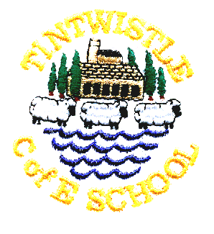
Tintwistle C. E. (A) Primary School
‘Confidence, Competence, Creativity’

Newsletter number 32 17th June 2015

Visit from St Luke’s
Each year two of our school council members take part in the pupil forum and visit other schools to discuss issues that affect children in the Glossop area. This year our representatives have been Freya and Sandhya. At a recent meeting the pupils discussed how they would all like the opportunity to visit other schools and take part in joint activities, so the girls invited them to come to Tintwistle to have a go at cheerleading. St. Luke’s were very keen to take up the offer so on Tuesday twenty one of their older pupils came to watch a demonstration and learn some moves. All the children had a fantastic time and we are looking forwards to visiting St. Luke’s soon. Good luck to all the cheerleaders for their competition at Manchester Velodrome on Saturday.

Well Dressing
This year’s well dressing will be at 7.00pm on 26th June. The service will begin at Holy Well and will be followed by the blessing of the children’s well at the United Reformed Church. The picture is Jack and the Beanstalk, which has been picked to fit with the Children's Gala theme - 'Celebrating 100 Years of Ladybird Books'. The well dressing will be created in school from Monday 22nd until Thursday 25th June (1 - 3.30pm) giving our pupils an opportunity to contribute to the project. We're more than happy for adult helpers to join us. You don't need to be creative or arty, just patient, as the work is fiddly. We're keen to keep this Derbyshire tradition alive, so the more people who see how it is made the greater the chance that our school will continue to take part in the future. If you would like to help the children and have some time to spare please either let Vicky know or talk to us in the office.

Class 3 Drum Concert
Class 3 would like to invite you all to their drum and percussion concert at 11am on Thursday 25th June. They have really enjoyed their music lessons this year and are keen to show what they have learned. Next year class 3 will be learning to play brass instruments and class 4 will be learning the ocarina.

Tintwistle Gala
As we have been unable to find a float I can confirm that we will be walking in this year’s parade. Our theme is the seaside so you could keep it simple with beachwear or come up with something more imaginative. Footwear should be comfortable for the children to walk in. Children do not have to walk the whole route, if you think this would be too much for your child feel free to take them out of the parade part way round. We would also welcome as many parents as possible to walk with us, particularly to accompany the younger children. A letter will be sent home so that we know you are happy for your child to participate and what your preferred arrangements are.

TSA Fundraiser Bottle Stall at Children's Gala Saturday 27th
The TSA will be manning a bottle stall at the Gala next week. This event is a great fundraising opportunity for us but we need your support to guarantee success - the more bottles we have the more money we make! There'll be a non-uniform day Friday 26th June in exchange for bottles for our stall. The bottles will be covered by bottle bags, so if you have any spare bags we'd be grateful for them. Also bear in mind the size of a normal bottle bag when you pick which bottles you'll be bringing in! Thanks for your help.

Staff Training Day
Please don’t forget that school will be closed for staff training on Monday 29th June

Jo Griffin, Headteacher

