Reception | The World Autumn 1 (8 Weeks) |  |  |  |  |  |  |  |  | Marvellous Me Autumn 2 ( 7 weeks )
Writing Root Text | 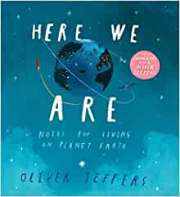  Here we are by Oliver Jeffers Whole School Text |  |  | 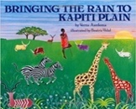  Bringing the Rain to Kapiti Plain  Verma Aardema |  |  | 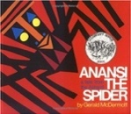  OR Anansi  Gerald McDermott |  |  | 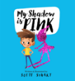  My Shadow is Pink  Scott Stuart | 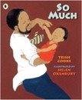  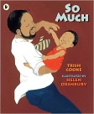  So Much  Trish Cooke and Helen Oxenbury |  |  |  | 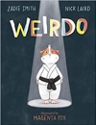  Weirdo  Zadie Smith and Nick Laird |  | 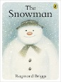  The Snowman  Raymond Briggs  Whole School Text  The Snowman  Raymond Briggs  Whole School Text
Theme/Term | Once Upon aTime Spring 1 (6 Weeks) |  |  |  |  |  |  |  |  | Infinity and beyond Spring 2 ( 5 weeks)
Writing Root Text | 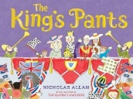  The King’s Pants by Nicholas Allen |  |  | 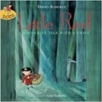  Little Red  Lynn Roberts and David Roberts |  |  | 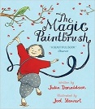  The Magic Paintbrush Julia Donaldson and Joel Stewart |  |  | 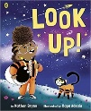  Look up! by  Nathan Bryon and Dapo Adeola |  | 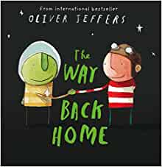  The Way Back Home by Oliver Jeffers |  |  |  | 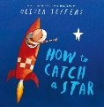  How to Catch a Star  Oliver Jeffers
Theme/Term | Sailing the Seven Seas Summer 1 ( 6 weeks) |  |  |  |  |  |  |  |  | Superheroes Summer 2 (7 Weeks)
Writing Root Text | 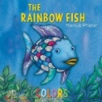  The Rainbow Fish by Marcus Pfister | 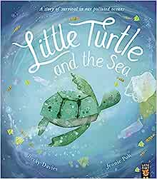  Little Turtle and the Sea by Becky Davies |  |  |  | 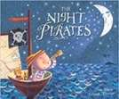  The Night Pirates  Pete Harris and Deborah Allwright |  |  |  | Super Milly and the Super School Day by  Stephanie Clarkson  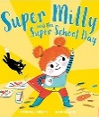 | 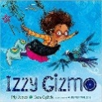  Izzy Gizmo by Pip Jones |  |  |  | 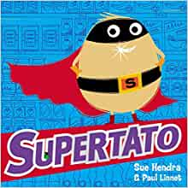  Supertato by Sue Hendra
Year 1 | The World Autumn 1 |  |  |  |  |  |  |  |  | The World Autumn 2
Writing Root/  Spelling Seed Text | Here we are by Oliver Jeffers Whole School Text | 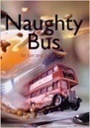  OR Naughty Bus  Jan Oke and Jerry Oke |  |  | 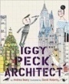  OR Iggy Peck, Architect  Andrea Beaty and David Roberts |  |  |  |  | 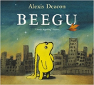  Beegu  Alexis Deacon |  | The Snowman  Raymond Briggs  Whole School Text
Theme/Term | Once Upon a Time Spring 1 |  |  |  |  |  |  |  |  | Once Upon a Time Spring 2
Writing Root/  Spelling Seed Text | 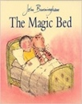  The Magic Bed  John Burningham | 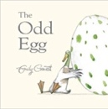  The Odd Egg  Emily Gravett |  |  |  |  |  |  |  | 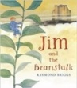  Jim and the Beanstalk  Raymond Briggs |  | Cinderella An Art Deco Fairy Tale Lynn Roberts and David Roberts  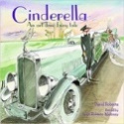
Theme/Term | Ship Ahoy Summer 1 |  |  |  |  |  |  |  |  | Ship Ahoy Seas Summer 2
Writing Root/  Spelling Seed Text | 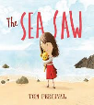  Sea-Saw  Tom Percival | 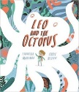  Leo and the Octopus- Isabelle Marinov |  |  |  |  |  |  |  | 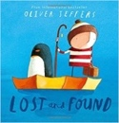  Lost and Found  Oliver Jeffers | 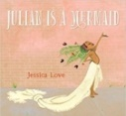  Julian is a Mermaid  Jessica Love
Year 2 | The World Autumn 1 |  |  |  |  |  |  |  |  | The World Autumn 2
Writing Root/  Spelling Seed Text | Here we are by Oliver Jeffers Whole School Text |  |  | 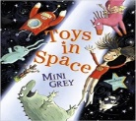  Toys In Space  Mini Grey |  |  | 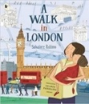  A Walk in London  Salvatore Rubbino |  |  | 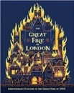  The Great Fire of London  Emma Adams | 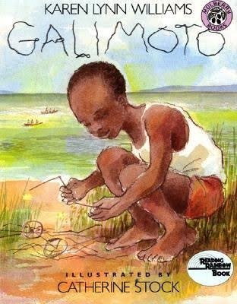  Galimoto  Karen Lynn |  |  |  | 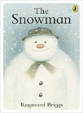  The Snowman  Raymond Briggs  Whole School Text
Theme/Term | Once Upon a Time Spring 1 |  |  |  |  |  |  |  |  | Once Upon a Time Spring 2
Writing Root/  Spelling Seed Text | 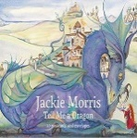  Tell Me a Dragon  Jackie Morris |  |  | 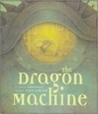  The Dragon Machine  Helen Ward |  |  |  |  |  | 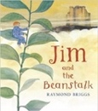  Jim and the Beanstalk  Raymond Briggs | Cinderella An Art Deco Fairy Tale Lynn Roberts and David Roberts |  |  |  | 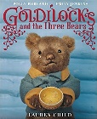  Or Goldilocks  Lauren Child
Theme/Term | Ship Ahoy Seas Summer 1 |  |  |  |  |  |  |  |  | Ship Ahoy Summer 2
Writing Root/  Spelling Seed Text | The Night Pirates  Pete Harris and Deborah Allwright |  |  | 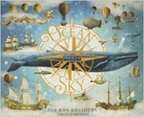  Ocean Meets Sky  Eric Fan and Terry Fan |  |  |  |  |  | 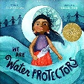  We Are Water Protectors  Carol Lindstrom | 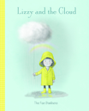  Lizzy and the Cloud  The Fan Brothers |  |  |  | 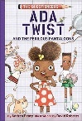  Ada Twist  Andrea Beaty  (Link to Science)
Year 3/4 | The World Autumn 1 |  |  |  |  |  |  |  |  | The World Autumn 2
Writing Root/  Spelling Seed Text | Here we are by Oliver Jeffers Whole School Text |  | 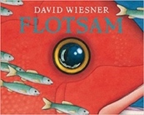  Flotsam  David Wiesner |  |  |  |  |  |  | 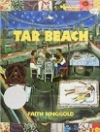  Tar Beach  Faith Ringgold | The Snowman  Raymond Briggs  Whole School Text
Theme/Term | The Roman Empire Spring 1 |  |  |  |  |  |  |  |  | Ancient Greece Spring 2
Writing Root/  Spelling Seed Text | 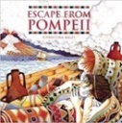  Escape from Pompeii  Christina Balit |  |  | 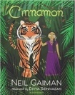  Cinnamon  Neil Gaiman |  |  | 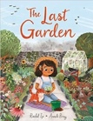  OR The Last Garden  Rachel Ip |  |  | 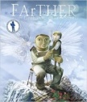  FArTHER  Grahame Baker Smith |  |  |  | 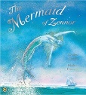  The Mermaid of Zennor  Charles Causley
Literary Leaf Text | 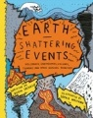  Earth Shattering Events  Robin Jacobs |  |  |  | 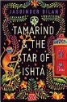  Tamarind and the Star of Ishta  Jasbinder Bilan |  |  |  |  | 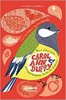  New and Collected Poems for Children  Carol Ann Duffy
Theme/Term | We are Biologists Summer 1 |  |  |  |  |  |  |  |  | We are Biologists Summer 2
Writing Root/  Spelling Seed Text | 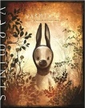  Varmints  Helen Ward | 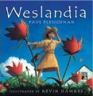  Weslandia  Paul Fleischman |  |  |  |  |  |  |  | 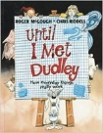  Until I Met Dudley  Roger McGough and Chris Riddell |  | Jabberwocky  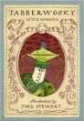  Lewis Carroll
Literary Leaf Text | 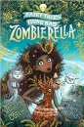  Zombierella  Joseph Coelho |  |  |  | The Humans: Ancient civilisations  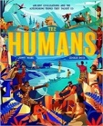  Jonny Marx |  |  |  |  | 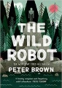  The Wild Robot  Peter Brown |  |  |  |  | 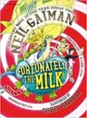  Fortunately, the Milk  Neil Gaiman
Year 5/6 | The World Autumn 1 (8 Weeks) |  |  |  |  |  | The World Autumn 2 (7 Weeks)
Writing Root /  Spelling Seed Text | Here we are by Oliver Jeffers | 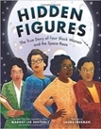  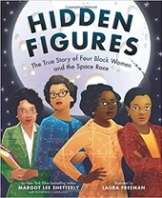  Hidden Figures  Margot Lee Shetterly |  |  |  |  | 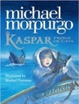  Kaspar, Prince of Cats  Michael Morpurgo |  | The Snowman  Raymond Briggs  Whole School Text
Literary Leaf Text |  |  |  |  |  |  | 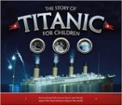  The Story of Titanic for Children Joe Fullman
Theme/Term | Ancient Civilisations Spring 1 (6 Weeks) |  |  |  |  |  | Spring 2 (5 Weeks)
Writing Root /  Spelling Seed Text | 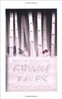  Grimm Tales for Young and Old Phillip Pullman | SPAG/SATS Revision |  |  |  |  | 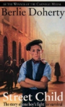  The Street Child by Bertie Doherty
Literary Leaf Text | Grimm Tales for Young and Old Phillip Pullman |  |  | 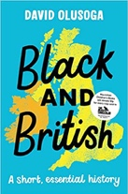 |  |  | The Street Child by Bertie Doherty
Theme/Term | Invaders and Settlers Summer 1 (6 Weeks) |  |  |  |  |  | Invaders and Settlers Summer 2 (7 Weeks)
Writing Root /  Spelling Seed Text | 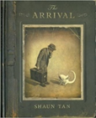 |  |  |  |  |  | OR Firebird  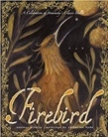  Saviour Pirotta and Catherine Hyde | 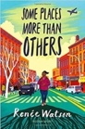  Some Places More Than Others  Renee Watson
Literary Leaf Text | 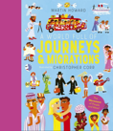  A World Full of Journeys and Migrations  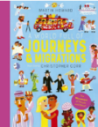  Martin Howard |  |  |  |  | 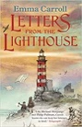 | 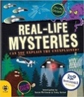  Real-life Mysteries  Susan Martineau and Vicky Barker

