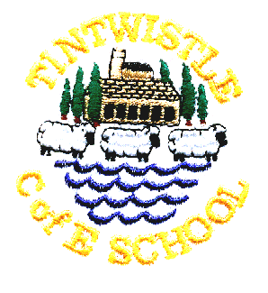
Tintwistle C. E. (A) Primary School

9.12.20

Dear Parents and Carers,
There has been lots of speculation in the press this morning about schools shutting early for Christmas and I am sure that you would like some clarity.
School will be open as planned on Friday 18th December, we will reopen on Tuesday 5th January (Monday 4th is a staff training day).

Yesterday the DfE suggested that schools could change their staff training days around in order to reduce the burden of track and trace upon schools. We feel that this is insufficient notice for parents to change their childcare arrangements and so will be sticking to our original dates.

Please see below for extracts from the DfE guidance.

Public Health England has agreed a 6 day window after the final day of teaching in which schools and further education providers are asked to remain contactable so they can assist with contact tracing where necessary. This will allow enough time for positive coronavirus (COVID-19) cases to be identified and confirmed by a test and for relevant contacts in the education setting to be traced. We are clear that beyond 6 days after the final day of teaching, school and further education staff are not asked to play a role in any contact tracing. It is also likely that the need to support the tracing process will reduce dramatically over the course of the 6 days as the majority of cases should be identified earlier in the week.
We recommend all schools ensure staff, parents and carers are aware of the following information and relevant arrangements regarding positive cases in the holidays:
- Where a pupil or staff member tests positive for coronavirus (COVID-19), having developed symptoms more than 48 hours since being in school, the school should not be contacted. Parents and carers should follow contact tracing instructions provided by NHS Test and Trace.
- For the first 6 days after teaching ends, if a pupil or staff member tests positive for coronavirus (COVID-19), having developed symptoms within 48 hours of being in school, the school is asked to assist in identifying close contacts and advising self-isolation, as the individual may have been infectious whilst in school.
- School staff are not asked to remain on-call or conduct any contact tracing more than 6 days after the final day of teaching.
For the first 6 days after the end of term, schools are not asked to be on-call at all times. Staff responsible for contact tracing may designate a limited period in the day to receive notification of positive cases and advise close contacts to self-isolate. The Department for Education coronavirus (COVID-19) helpline and PHE advice service are available to support with any queries about positive cases in school.
Where pupils are required to self-isolate due to contact with a positive case after the first 6 days following the end of term, schools do not need to be informed about their absence until the first day of the new term.
Following the above guidance please contact school only if your child has a positive test having developed symptoms within 48 hours of being in school. As the school office is not staffed over the holidays please use the number below, either by texting or calling between 10am and 2pm up to and including 24th December.
07391 993 648
Thank you for your support in helping us to keep everyone safe. I know that many of us are making difficult decisions about seeing elderly and vulnerable friends and relations over Christmas. By getting tests for symptomatic children and reporting positive tests you are enabling our school community to make informed decisions and protect their loved ones.
I hope that all is going well with your Christmas plans and that you all have a safe and happy holiday. I am sure I am not alone in hoping that 2021 will be an improvement on 2020!
Jo Griffin, Headteacher

