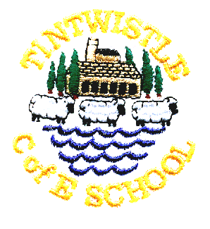
Tintwistle C. E. (A) Primary School
‘Confidence, Competence, Creativity’

Newsletter number 24 26th March 2015

Gift Day at Christ Church
Clara represented the school at Gift Day on Saturday and read her opening piece so well that she was asked to read other parts of the bible through the day, she also stayed to help out and attended the service on Sunday. Clara was very proud to be presented with a bible and really enjoyed her time at church.

School Church Service
At our Easter service yesterday prizes for the best pictures went to Amaya Hughes, Calum Smith, Issy Grant and Katie Winterbottom. Well done to everyone who took part.

Swimming Games
The Glossop swimming games are designed to be fun races which give children water confidence and were held this morning. Our team consisted of Jack Higginbottom, Jack Pedley, Abigail Speake, Millie Grant, Keira Hirst Megan Higginbottom and Paige Plant. The team were fantastic sports and cheered on the other teams as well as each other. Well done everyone, you made us proud!

Open Afternoon
Thanks to all those parents who came to our open afternoon. The children really enjoyed showing off all their topic work, we hope you had as much of a good time as they did and didn’t get too messy with all the glue and paint.

Easter Hats
Well done to everyone who brought in an Easter hat today – there were some amazing creations! Congratulations to Calum Smith, Lily Robson, Katie Winterbottom, Issy Grant Harvey Rayner and Ellie-Rose Bagshaw who all won Easter eggs.

We hope that everyone has a lovely Easter holiday; school is now closed until Monday 13th April.

Jo Griffin, Headteacher

