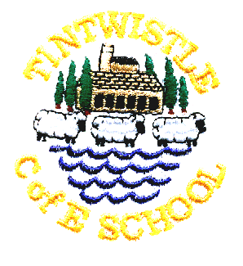
Tintwistle C. E. (A) Primary School

‘Confidence, Competence, Creativity’

20th October 201
Congratulations to Sue and Ignition!
We are absolutely delighted that Sue has won Volunteer Coach of the Year at the Derbyshire School Sports Awards. Ignition were highly commended in their category of Team of the Year and had the honour of performing at the presentation ceremony in Chesterfield yesterday – their stunts drew gasps from the audience who really hadn’t known what to expect! As ever the children were beautifully behaved and did us credit.
The awards recognise excellence across the county and our local High Peak Sports Partnership were proud to be represented, photos are already on their website and we will be uploading some to ours shortly.

Harvest Gifts
Thanks for your generous donations of food for the Longdendale Food Bank, which is based at St Mary’s Church in Hadfield. The food bank does an important job in supporting families through temporary hardship such as missed benefit payments or sickness. Referrals can be made through school if you know of anyone who is in need

Parents’ Evenings
Thank you to everyone who was kind enough to donate cakes for our parents evenings this week, it certainly helped to make everyone feel welcome. We were also very grateful for the large number of books brought in for the book swap.

Jo Griffin, Headteacher

Friends of Conduit Street Park
The Friends of Conduit Street Park are continuing their work to secure funding in order to develop the park and make it into a real asset for the community. They are currently bidding to bag a massive cash boost from the Tesco Bags of Help initiative.
The supermarket has teamed up with Groundwork on the initiative which sees grants of £12000, £10000 and £8000 – all cash raised from the 5p bag levy- being awarded to environmental groups and greenspace projects. Three groups in each of Tesco’s 416 regions have been shortlisted to receive the cash award, including Friends of Conduit Street Park. This month shoppers are being invited to head along to Tesco stores to vote for who they think should take away the top grant. Voting opens on 31st October and runs until 13th November. Please help to support your local park.
Thank you,

Friends of Conduit Street Park committee

