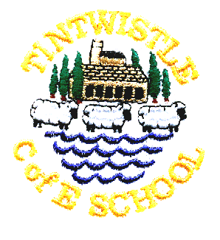
Tintwistle C. E. (A) Primary School

‘We learn and grow best together, with God, in a family of all
kinds of people, surrounded by encouragement and love.’
1.12.21

Christmas Play
This year’s play is ‘Children of the World’’ and all the children in the school, including nursery, are involved. Current government advice is that plays and nativities can go ahead with additional covid precautions, but that events should be cancelled if local or national advice changes. In order to comply with the recommended precautions please be aware of the following:
- Windows will be kept open – bring your coat!
- Masks must be worn
- Seating capacity has been reduced and we can only guarantee two tickets per family, we cannot guarantee that all families will receive tickets for their preferred performance. Tickets will be allocated on a first come first served basis. We understand that this will cause some disappointment as wider family members cannot watch the performances in school but we will make a recording available.
Monday’s show is a relaxed performance and younger siblings may attend, prams and pushchairs may be left under cover in the foundation stage play area, they cannot be brought into the hall. If younger siblings do not have a ticket they will need to remain on your knee for the whole performance. Please do not bring babies or younger children to the evening performances. Tickets are free and we are happy to accommodate wheelchairs but it is helpful if you let us know when booking (just note it on the slip). If you receive tickets and are unable to attend please let us know and we will reallocate them to the next person on the waiting list. Please do not attend if you have covid symptoms.

Please let us know if your child is unable to attend all the performances so that we can make alternative arrangements.

We will text with arrangements for drop off and pick up times next week, once we have timed the show.

School Carol Service – Wednesday 22nd December
Please meet at Christ Church at 9.00am, parents are welcome but are asked to wear a mask and socially distance as far as possible. Adults and children are invited to wear Christmas jumpers and any donations made for Christmas Jumper Day will be sent to Save the Children.

School closes for Christmas at 3.30pm on Wednesday 22nd December and re-opens on Monday 10th January.

Child’s name …………………………………………………………… Class …………………………………………………….

Please send me the following tickets Spares (if any available
(maximum 2 per family, pick one date only) maximum 2, one date only)

Monday 13th December at 2.00pm ……………. ……………

Tuesday 14th December at 6.30pm ……………. ……………

Thursday 16th December at 6.30pm ……………. ……………

No more than 2 tickets in each column (apologies if you think it is obvious but columns go downwards, rows go across. Ticking every box will not get you extra tickets!).

If you do not have a clear preference just note that on the slip. Tickets will be issued on Wednesday 8th December to the oldest child in the family. Spare tickets are most likely to be available for the Monday afternoon performance.

