Theme/Term | The World Autumn 1 |  |  | The World & Christmas Autumn 2
Planning Sequence | 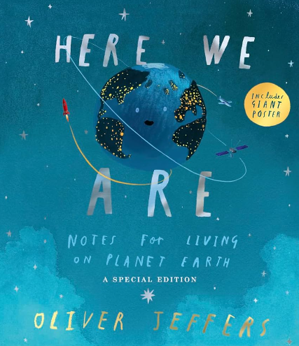  Here We Are  Oliver Jeffers  Whole School Text |  | 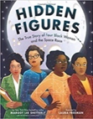  Hidden Figures  Margot Lee Shetterly | 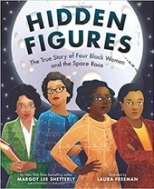  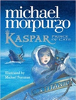  Kaspar, Prince of Cats  Michael Morpurgo |  | 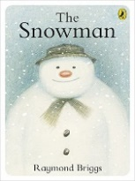  The Snowman  Raymond Briggs  Whole School Text
Length | 8 sessions, 2 weeks |  | 17+ sessions, 3+ weeks | 15 sessions, 3+ weeks
Outcomes |  |  | Memoirs  Reports, formal and informal letters, diaries, character descriptions, journalistic writing | Newspaper articles  Character descriptions, reports, letters, advertising leaflets, balanced reports |  | Own version of the narrative
Literacy Leaf Text |  |  |  | 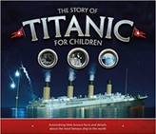  The Story of Titanic for Children Joe Fullman  15 sessions
Theme/Term | Spring 1 – Ancient Civilisations |  |  | Spring 2 – Ancient Civilisations
Planning Sequence | 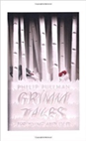  Grimm Tales for Young and Old  Phillip Pullman |  | SPAG Revision will take place and past Reading SATs Papers will also be sat this half term. | 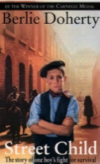  The Street Child by Bertie Doherty  15 sessions |  | SPAG Revision will take place and past Reading SATs Papers will also be sat this half term.
Length | 16 sessions, 4+ weeks |  | 2+ Weeks | 15 sessions, 3 weeks |  | 2+ Weeks
Outcomes | Own version traditional tales  Viewpoint retellings, character studies, monologues, character comparisons |  |  | Narrative  Character profile, diary entries, playscripts, letter writing
Literary Leaf Text | 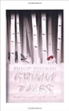  Grimm Tales for Young and Old  Phillip Pullman  15 sessions | SATs Reading papers |  | 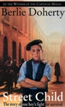  The Street Child by Bertie Doherty  15 sessions | SATs Reading Papers
Theme/Term | Summer 1 – We are Biologists |  |  | Summer 2 – We Are Biologists
Planning Sequence | 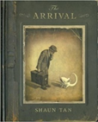  The Arrival  Shaun Tan | The children will be spending some time up levelling the writing in their writing folders this half-term. |  | 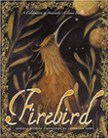  Firebird  Saviour Pirotta and Catherine Hyde | 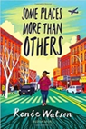  Some Places More Than Others  Renee Watson
Length | 17+ Sessions, 3+ Weeks |  |  | 10 sessions, 2 weeks | 15 sessions, 3 weeks
Outcomes | Extended own version narratives  Letters, lists of rules, character descriptions, diaries, short playscripts, short reports, guides |  |  | Fairytale narratives  Formal letters, retellings, character descriptions | Poems with similar structure  Summaries, analysis and performances
Literacy Leaf Text | 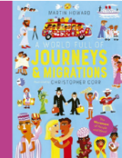  A World Full of Journeys  and Migrations  Martin Howard |  |  | 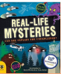  Real-life  Mysteries  Susan  Martineau and  Vicky Barker

