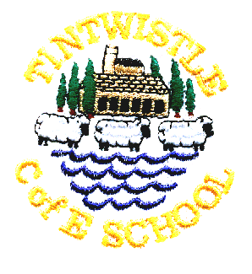
Tintwistle C. E. (A) Primary School
‘Confidence, Competence, Creativity’

Newsletter number 25 16th April 2015

PAS
Please note that there will be no good work assembly tomorrow as PAS will be presenting their sporting activities.

TSA
There will be a TSA meeting at 9.10am tomorrow, everyone welcome.

Book Fair
Our book fair will be open at 9.00am and 3.30pm from Friday 17th to Wednesday 22nd. There are a wide range of books available and we are accepting World Book Day vouchers.

Nursery/Reception Open Morning
We will be holding an open morning on Thursday 23rd April and both current and prospective parents are very welcome to call in and see our Foundation Stage Unit in action.

Class 4 Topic – Ancient Greece
As part of their Ancient Greece topic class 4 will be having a Greek party later in the term and will be making chitons (a bit like togas) to wear. We would be very grateful for any donations of old, unwanted sheets to use,

News from Christ Church
Christ Church's Spring Fair will be on April 25th from 10am - 1pm at the Church. There will be lots of stalls, including plants, crafts, tombola, refreshments and a cake stall. The speciality of the morning is Darrah's Play-Your-Cards-right; he will be ably supported by ‘dolly-dealers’ Tracey Smith-Lowe and Rachael Gregson which should be fun. Everyone is welcome.

Christ Church will finally be having their new Priest-in Charge on 15th June and there will be a formal installation on this date.

Jo Griffin, Headteacher

